**HOSPITAL MANAGEMENT APPLICATION**

**1.Introduction**

**1.1 Project Overview**  
The Hospital Management Application aims to streamline hospital operations by integrating patient management, appointment scheduling, billing, inventory management, and staff scheduling. This Salesforce-based application will centralize data, automate key processes, and enhance productivity in hospitals.

**1.2 Purpose of the Document**  
This document provides a comprehensive overview of the design, architecture, and implementation strategy for the Hospital Management Application.

**1.3 Purpose of the Project**  
The project focuses on simplifying and digitizing the management of hospital functionalities. The solution will enable efficient data handling, automation of critical tasks, and real-time updates on operations.

**1.4 Project Scope and Objectives**  
The project includes creating a scalable application to:

* Manage patient information, appointments, and billing.
* Track and manage inventory.
* Facilitate hospital staff scheduling.
* Generate key performance reports and dashboards.

**1.5 Key Stakeholders**

* Hospital Administrator: Manages hospital operations and oversees the application.
* Doctors and Nurses: Use the application to manage patient data, schedule appointments, and update medical records.
* Billing Specialist: Manages invoicing and billing processes.
* Inventory Manager: Oversees medical supplies and equipment tracking.

**2. Requirements Gathering and Analysis**

**2.1 Use Case Analysis**  
The application addresses core use cases in hospital operations: patient information storage, appointment scheduling, billing management, inventory control, and staff scheduling.

**2.2 Functional Requirements**

* Patient registration and record management.
* Appointment booking and rescheduling.
* Billing generation based on services provided.
* Inventory tracking and low-stock alerts.
* Staff scheduling and attendance monitoring.

**2.3 Non-functional Requirements**

* Data security with role-based access.
* High availability and scalability for multiple users.
* User-friendly interface for staff with varying technical expertise.

**2.4 Data Requirements**

* Storage of patient demographics, billing, and inventory information.
* Secure handling of sensitive data like patient medical history and billing.

**3. Architecture and System Design**

**3.1 Data Model Design**  
**3.1.1Custom Objects**

* Patient: Stores demographic, medical, and insurance information.
* Appointment: Manages scheduling details.
* Doctor: Holds doctor-specific information, including department and specialization.
* Room: Details room allocations for procedures.
* Equipment: Tracks medical equipment.
* Billing: Manages invoicing and payments.
* Staff: Tracks hospital employee information.
* Attendance: Tracks attendance of staff.

**3.1.2 Fields and Relationships**

* Patient - Appointment: One-to-many relationship to track multiple appointments for a patient.
* Doctor - Appointment: One-to-many relationship for doctor-patient appointments.
* Room - Appointment: One-to-many relationship to assign rooms to appointments.
* Room - Equipment: Many-to-many relationship for room equipment requirements.
* Patient - Billing: One-to-many relationship to link patient bills.
* Appointment - Billing: One-to-many relationship to associate billing records with appointments.

**3.1.3 Record Types and Page Layouts**

* 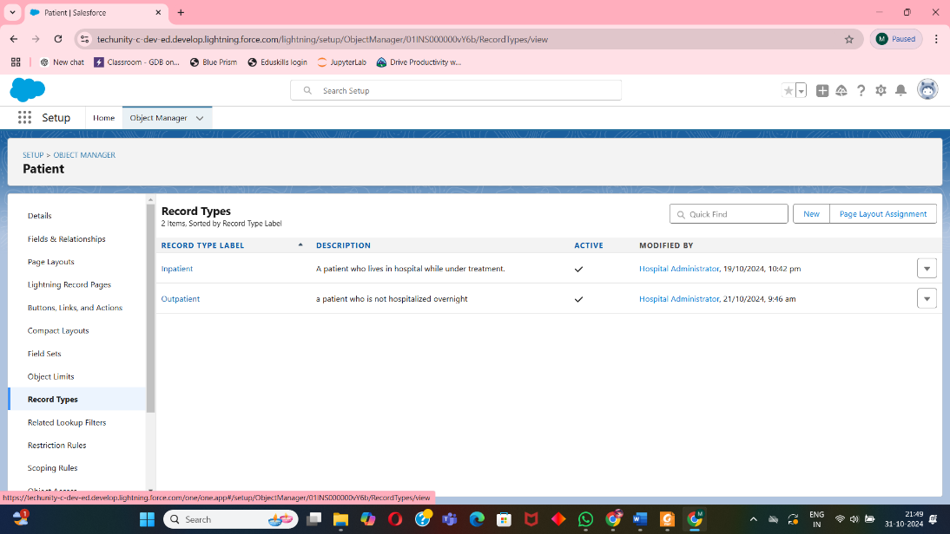**Patient Record Types**: Inpatient, Outpatient with tailored page layouts for each type.

**3.2 Security Model**  
**3.2.1Role Hierarchy**  
Roles include Hospital Administrator, Doctor, Nurse, Billing Specialist, and Inventory Manager with permissions scoped to their responsibilities.

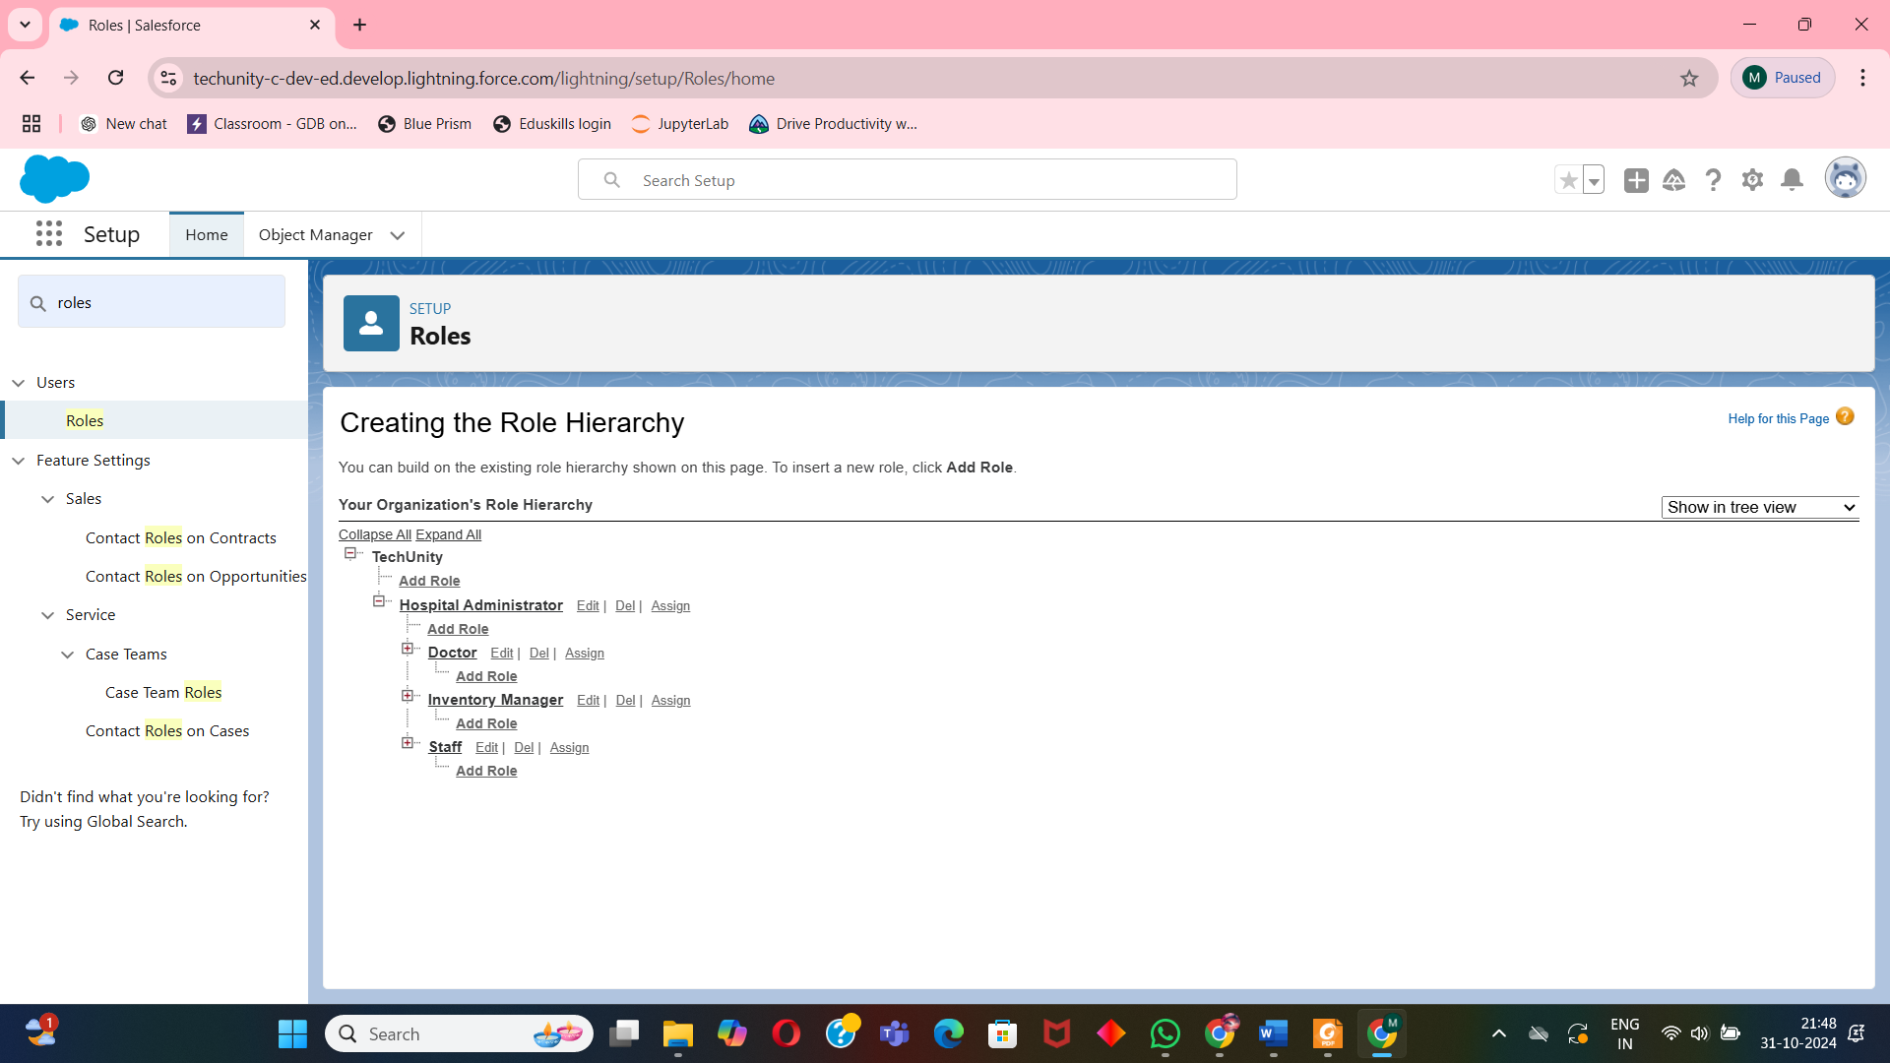

**3.2.2 Profiles and Permissions**  
Profiles control access, allowing administrators to view and manage all data while restricting data access for other roles.

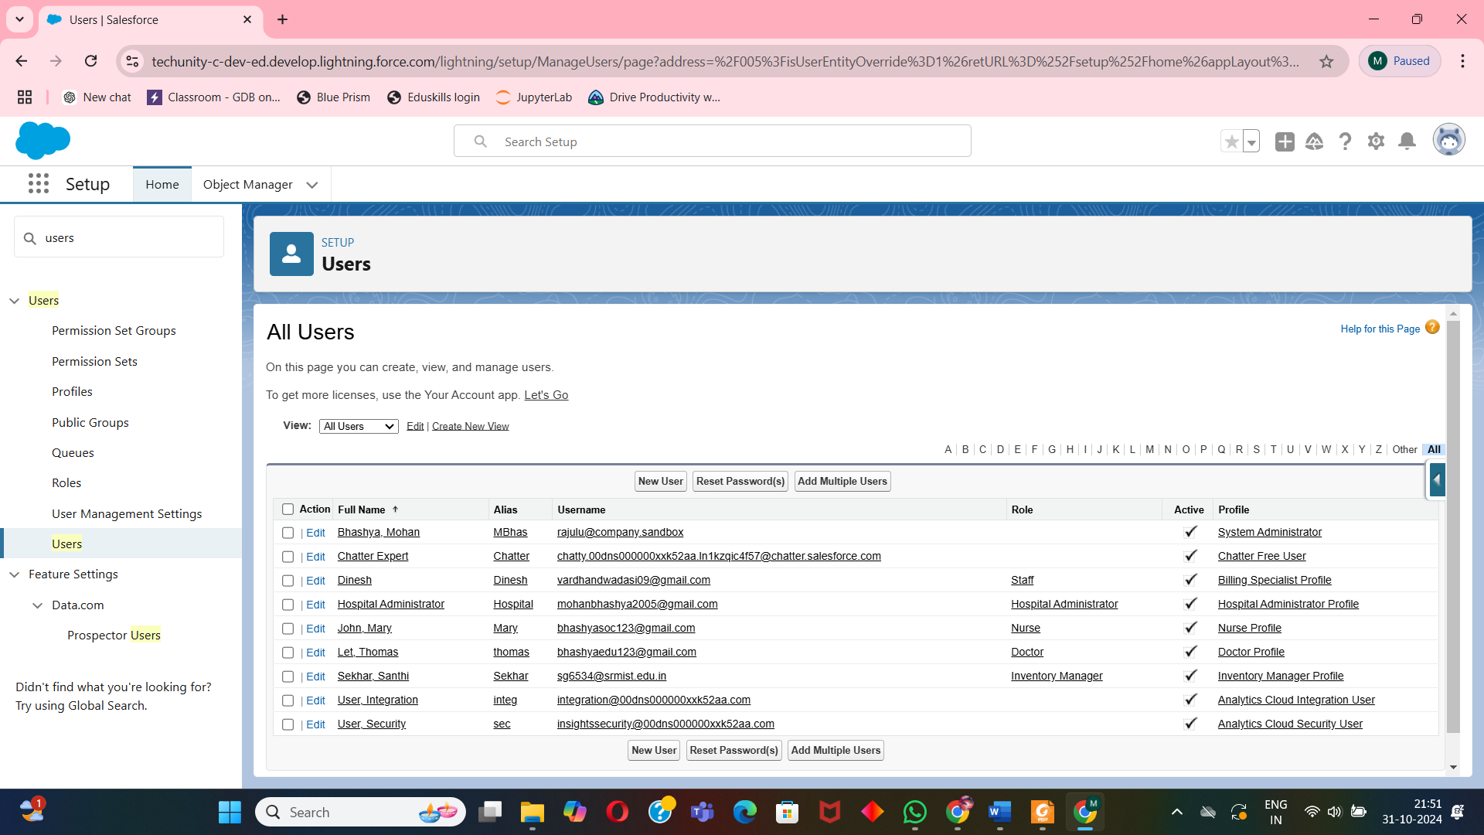

**3.3 Flow and Use Journey**  
Automated flows will:

* Send appointment reminders.

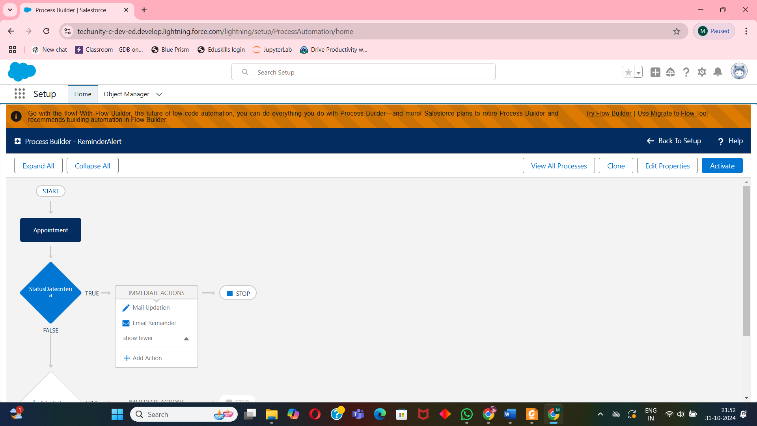

* Generate bills post-appointment.

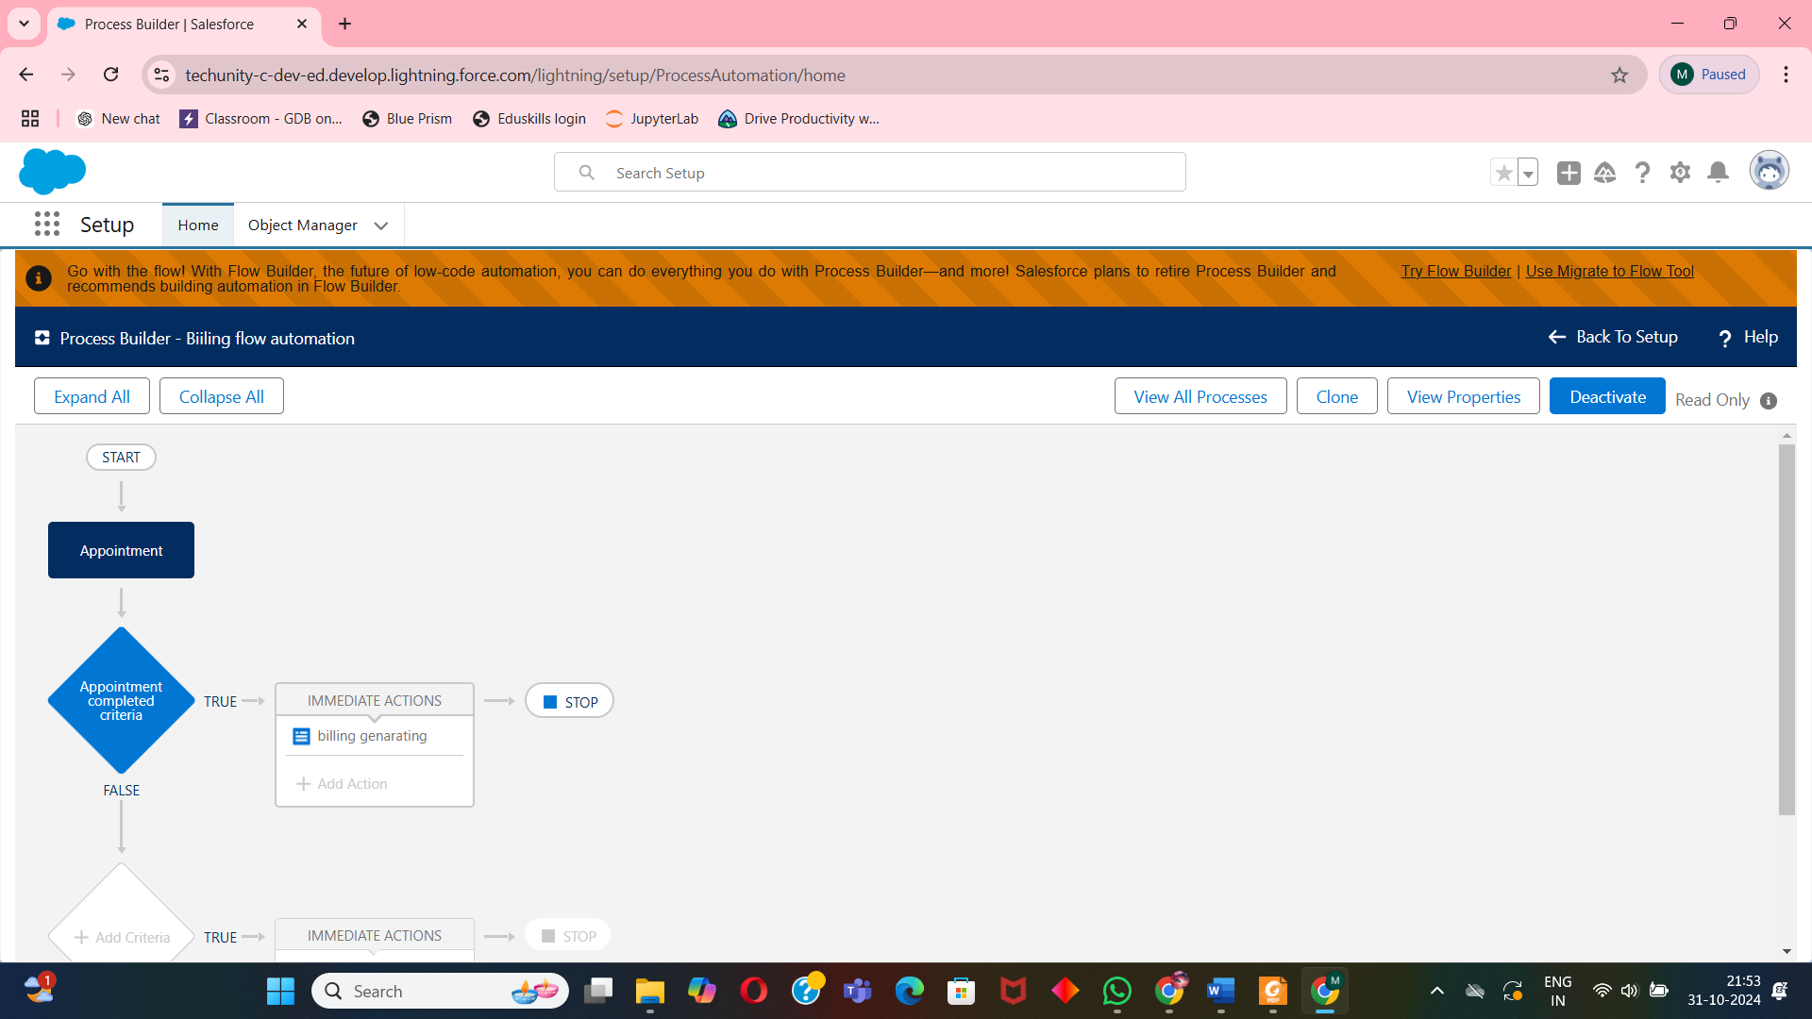

* Trigger low-stock alerts for inventory.

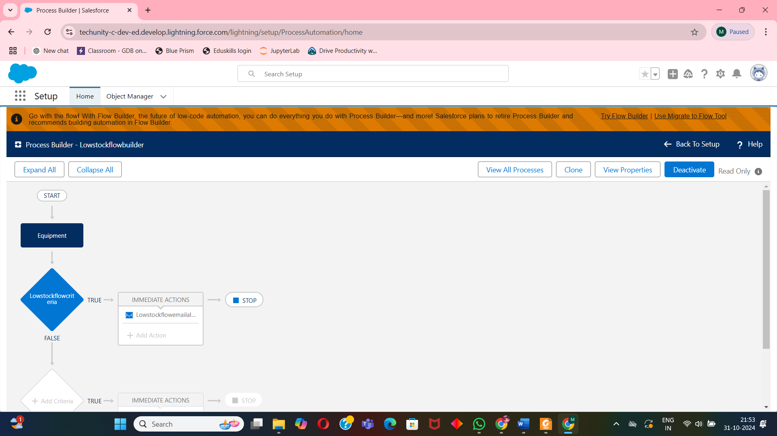

**3.4 Apex Class, Apex Trigger, and Test Class**

* **Apex Class**: Custom classes in Apex will handle complex business logic, such as calculating billing, managing inventory levels, or automating appointment workflows.

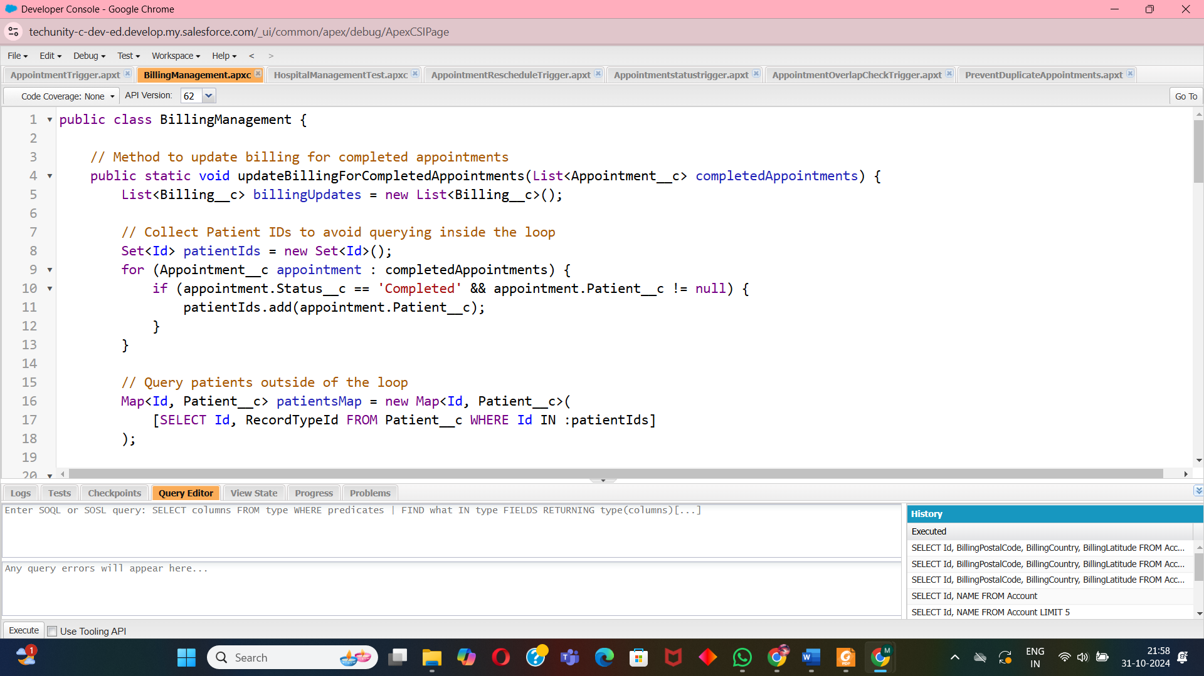

* **Apex Trigger**: Triggers will automate actions based on specific events, such as creating a billing record upon appointment completion or sending notifications for low inventory stock.

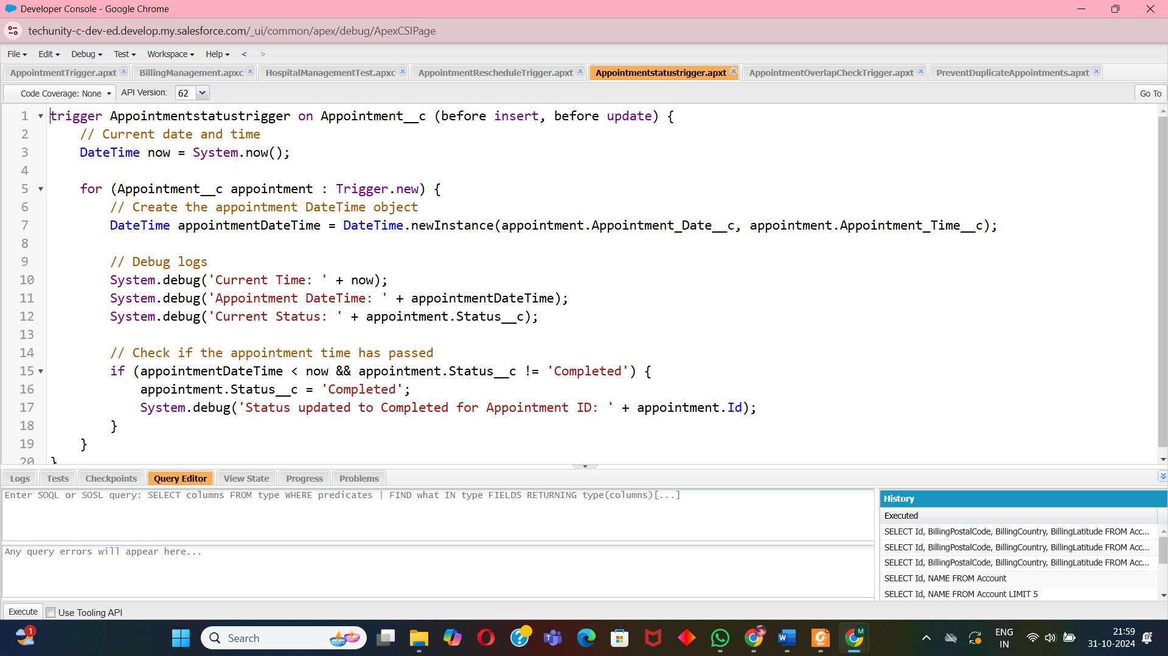

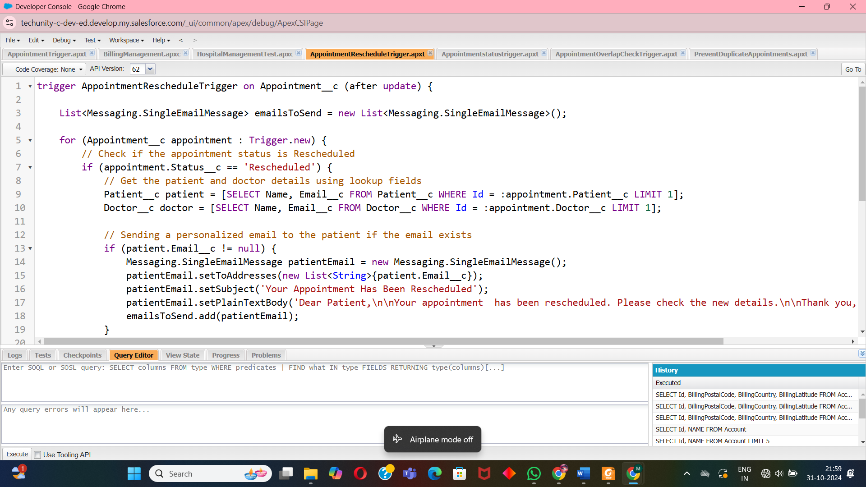

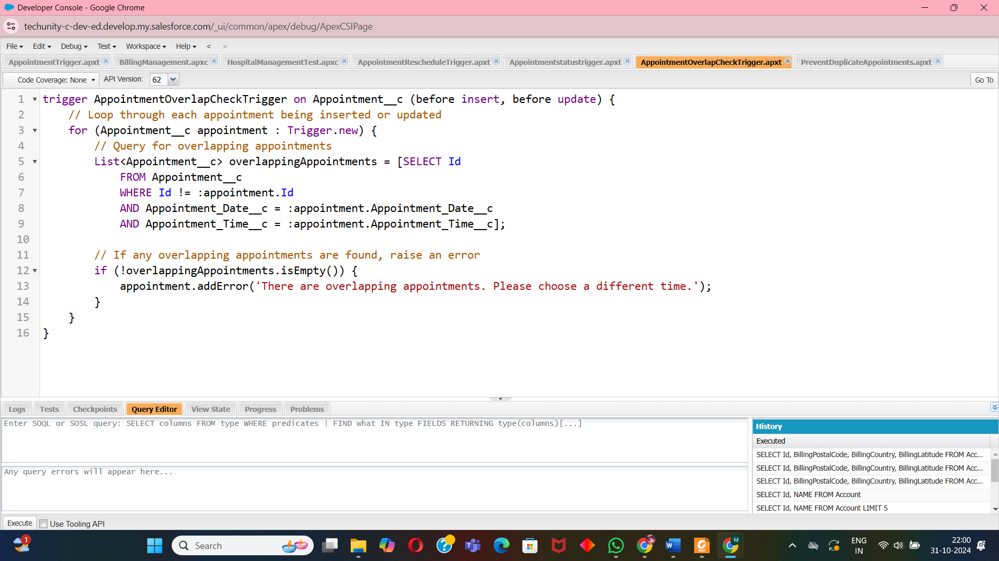

* **Test Class:** Each Apex class and trigger will have a corresponding test class to ensure code quality, validate functionality, and maintain high test coverage, essential for deployment in Salesforce.

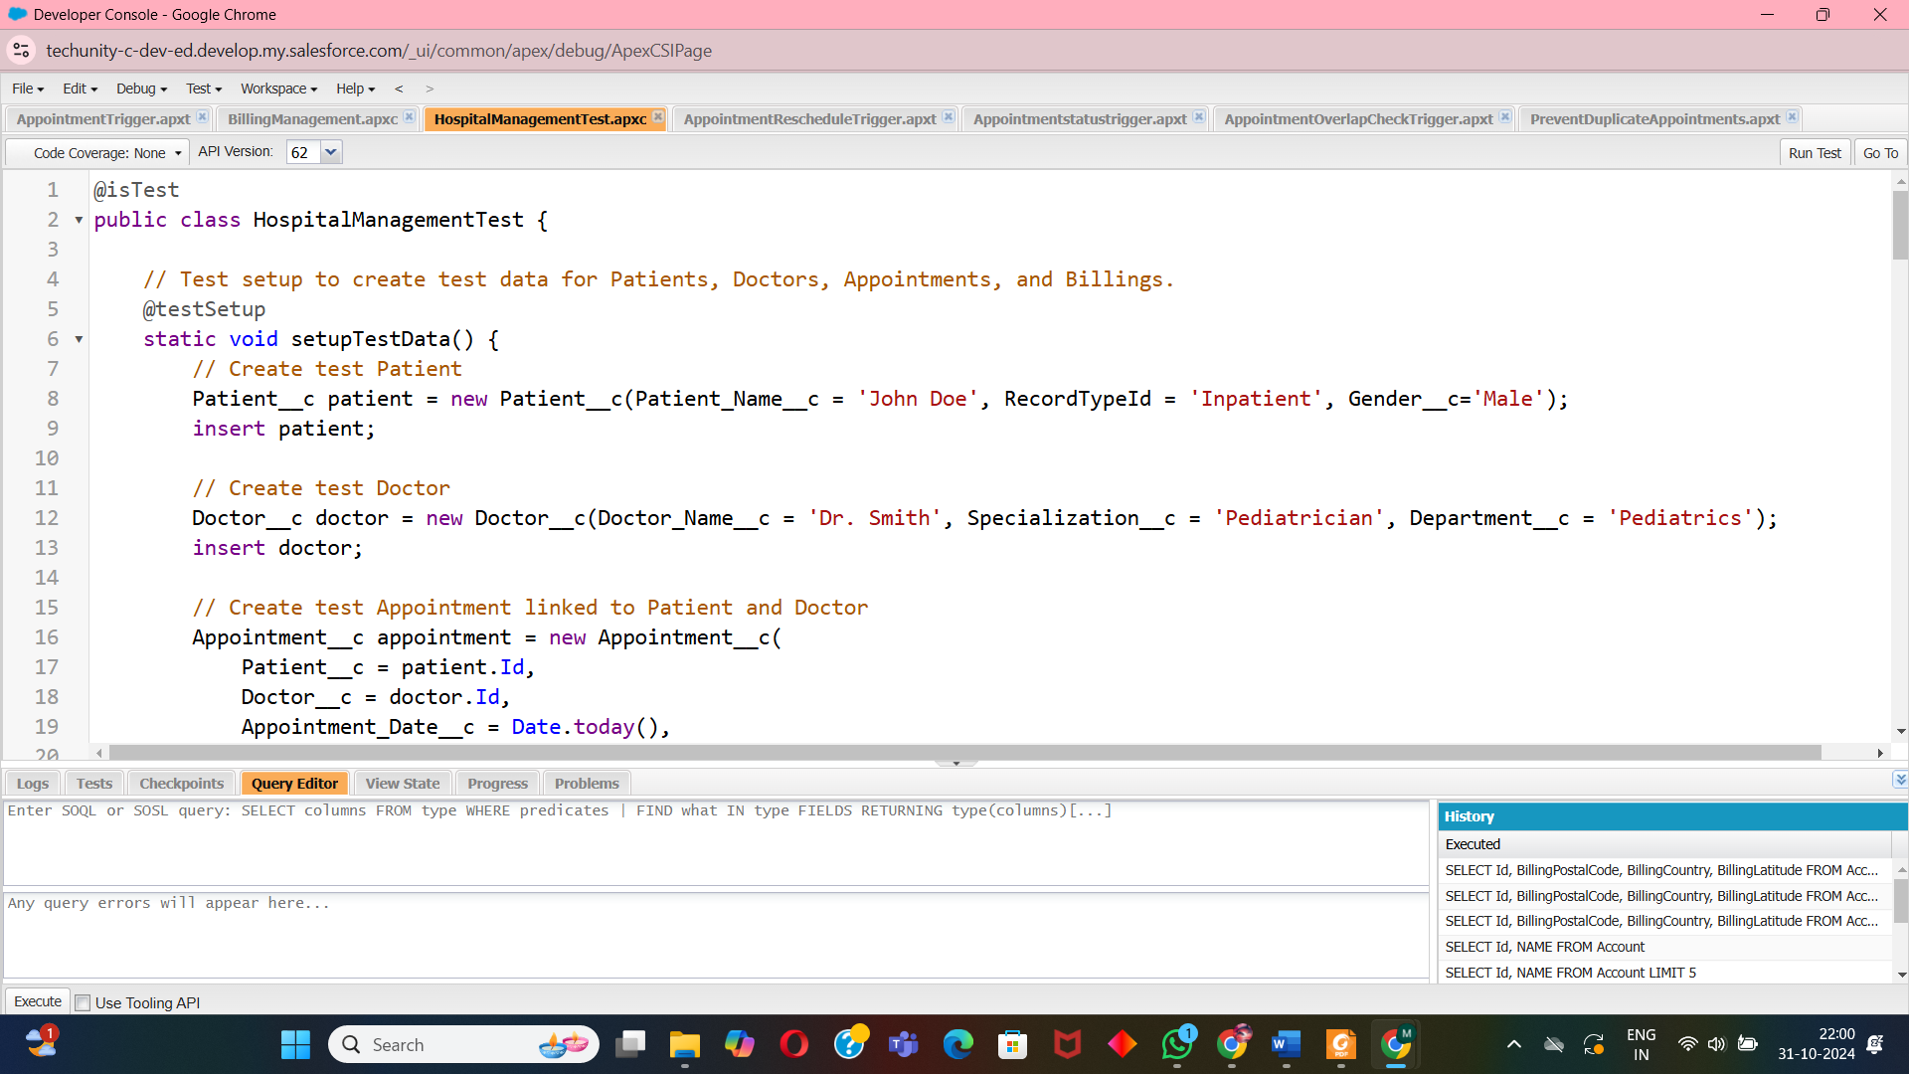

**4. MVP1 - Hospital Management Application Structure**

**4.1 Custom Object Creation**

* Patient Object: Captures patient demographic and medical information.

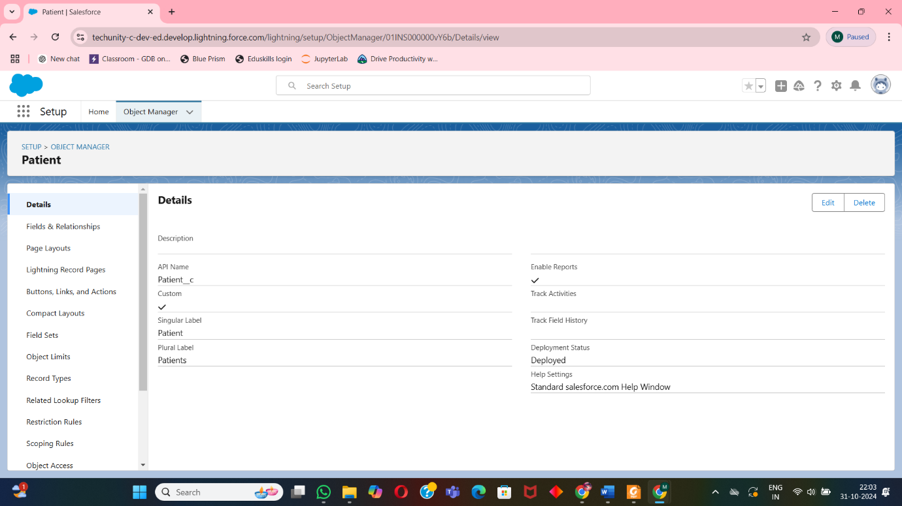

* Appointment Object: Schedules and manages patient appointments.

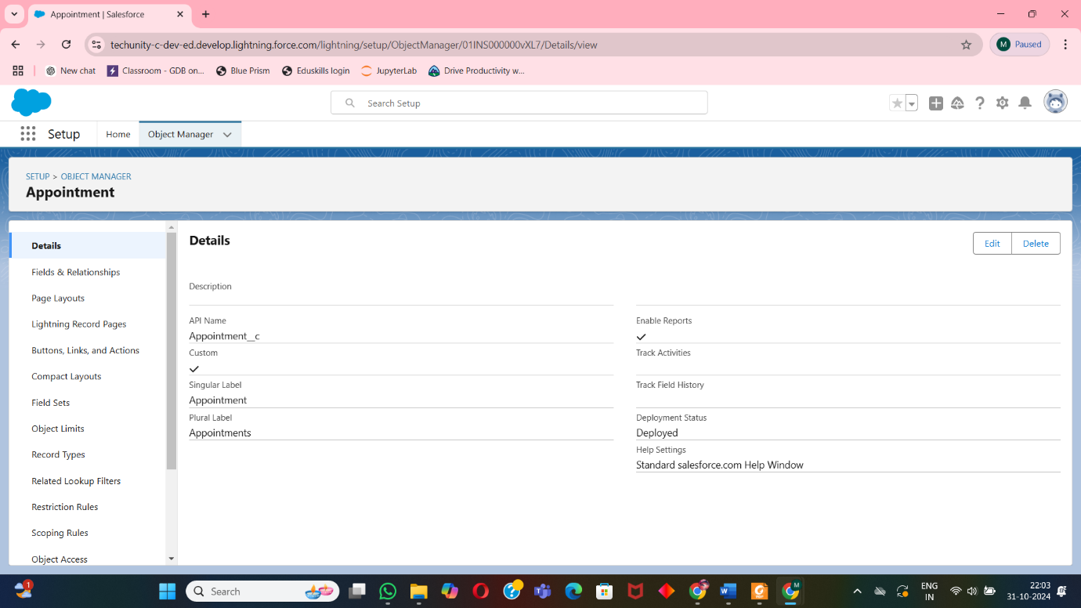

* Doctor Object: Details doctor specialization and department.

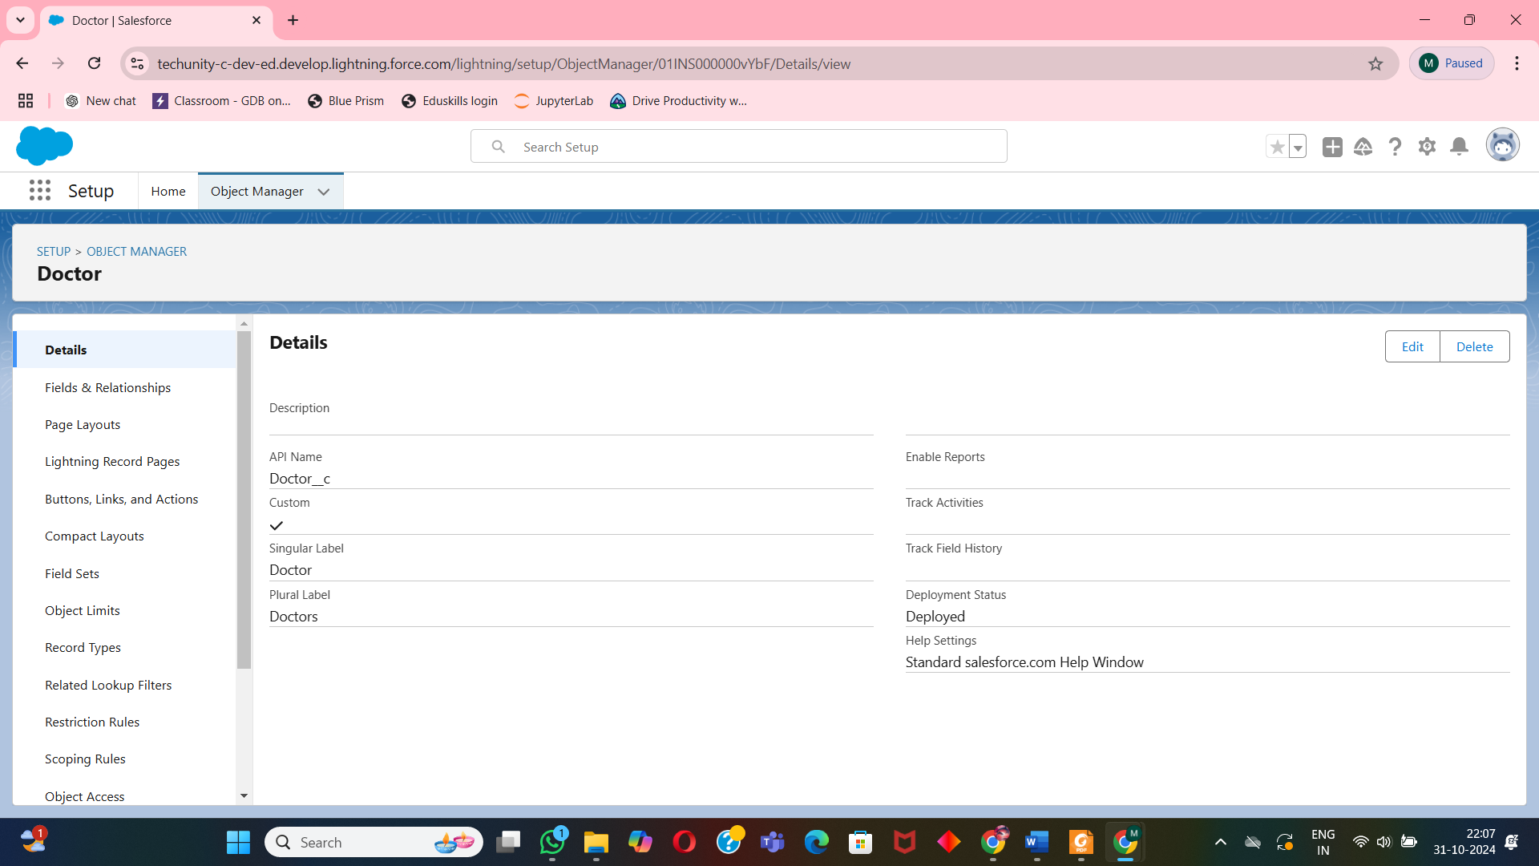

* Room Object: Manages room type and capacity for appointments.

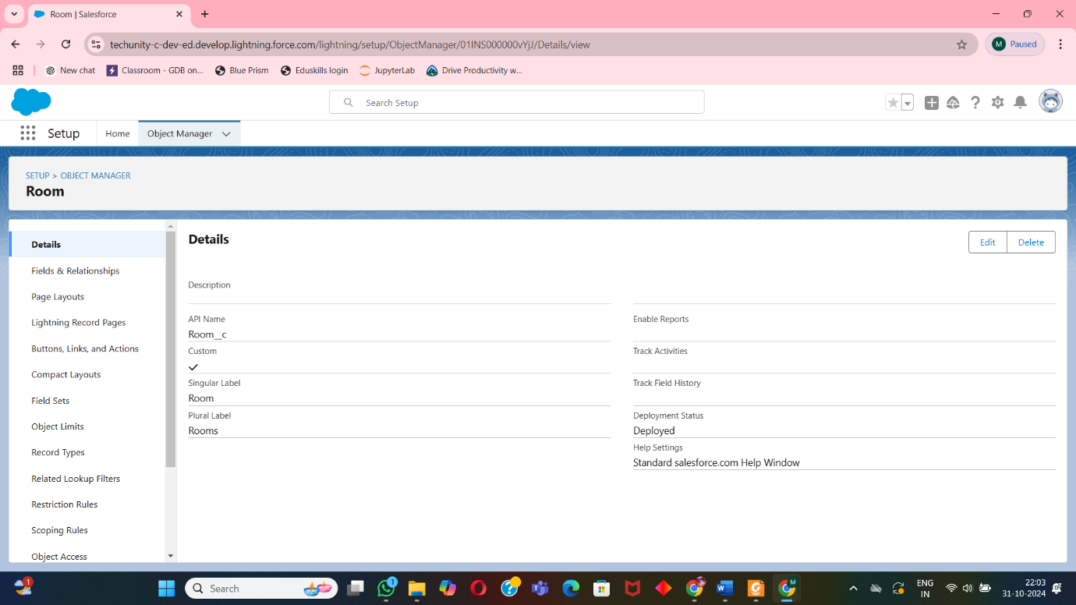

* Equipment Object: Tracks inventory details.

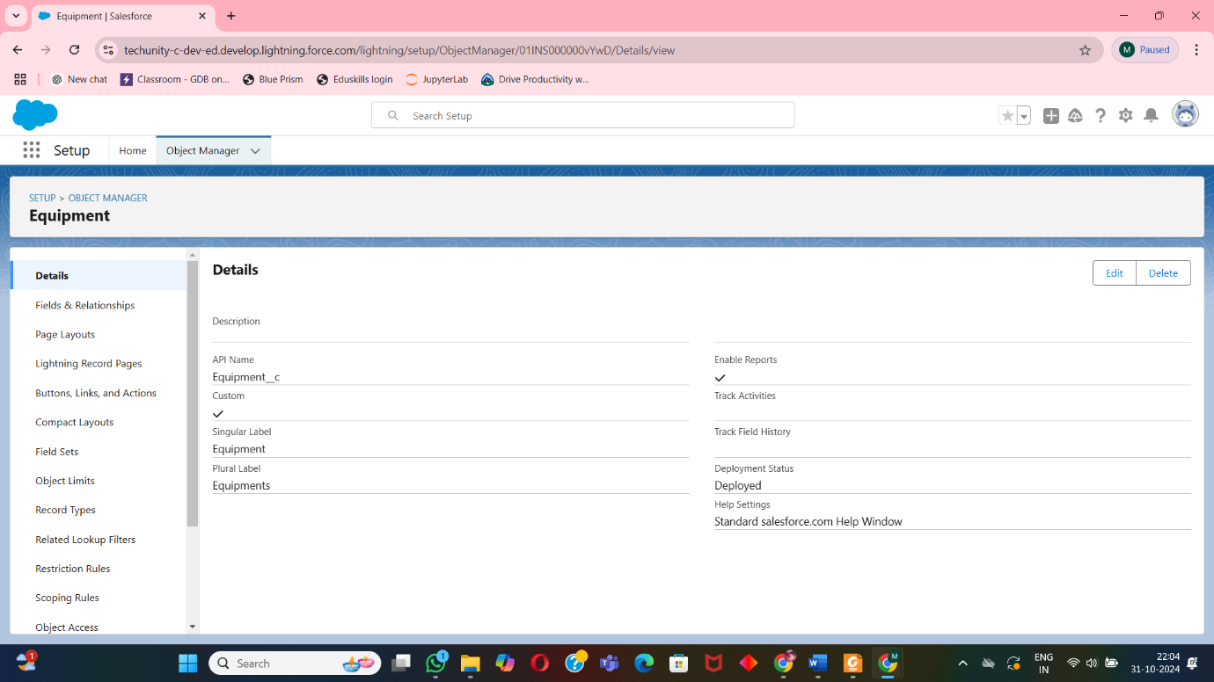

* Billing Object: Manages patient billing.

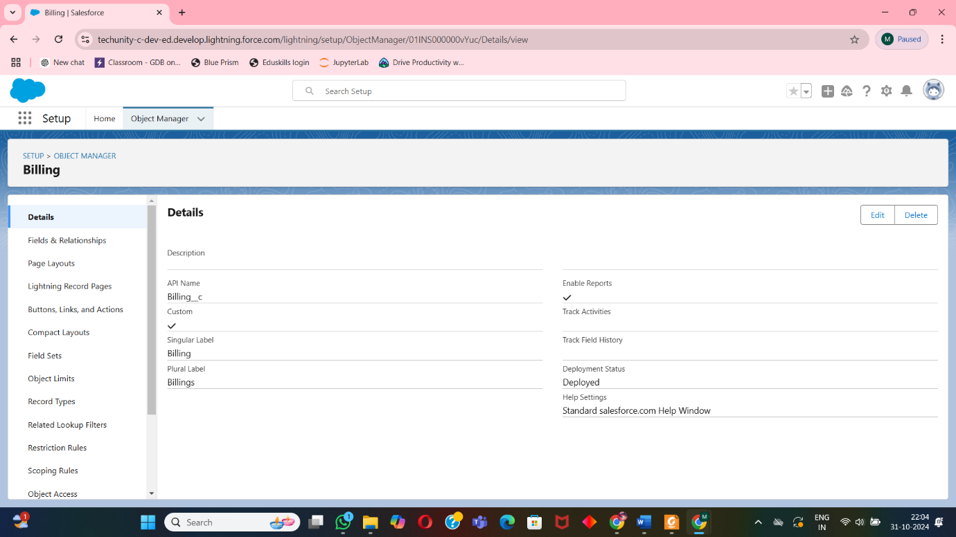

* Staff Object: Tracks staff job titles and schedules.

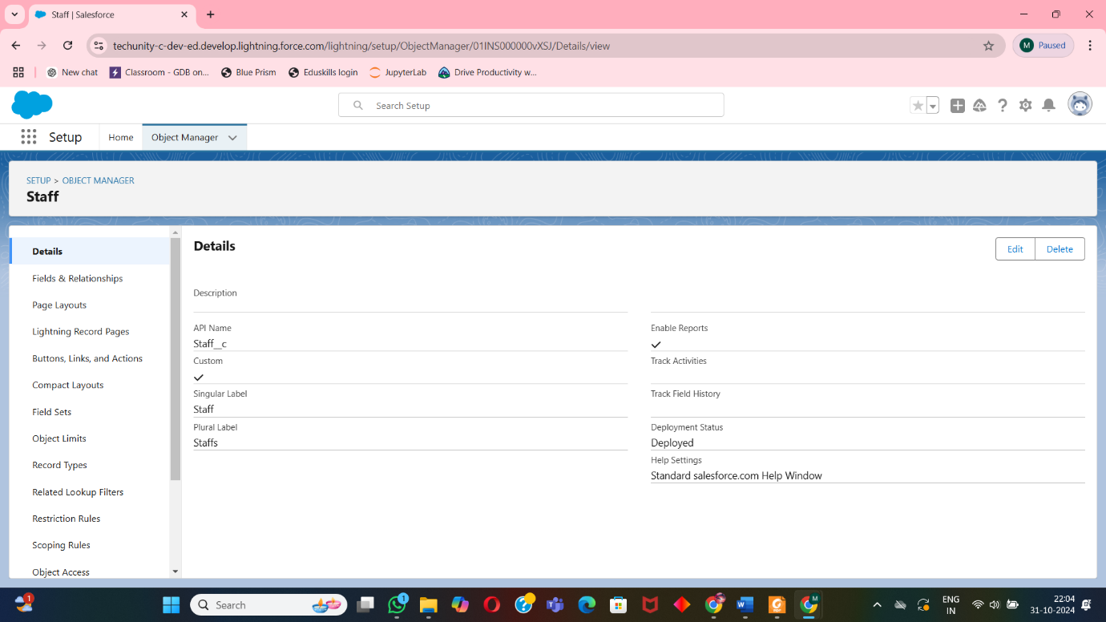

**4.2 Fields and Relationships**

Design of key relationships between objects:

* Patient Object:
  + Fields: Patient Name, Patient ID, Date of Birth, Gender, Contact Number, Address, Medical History, Insurance Information, Emergency Contact.
  + Relationships:
    - One-to-Many relationship with Appointments to track multiple appointments for each patient.
    - One-to-Many relationship with Billing to manage billing details for each patient.

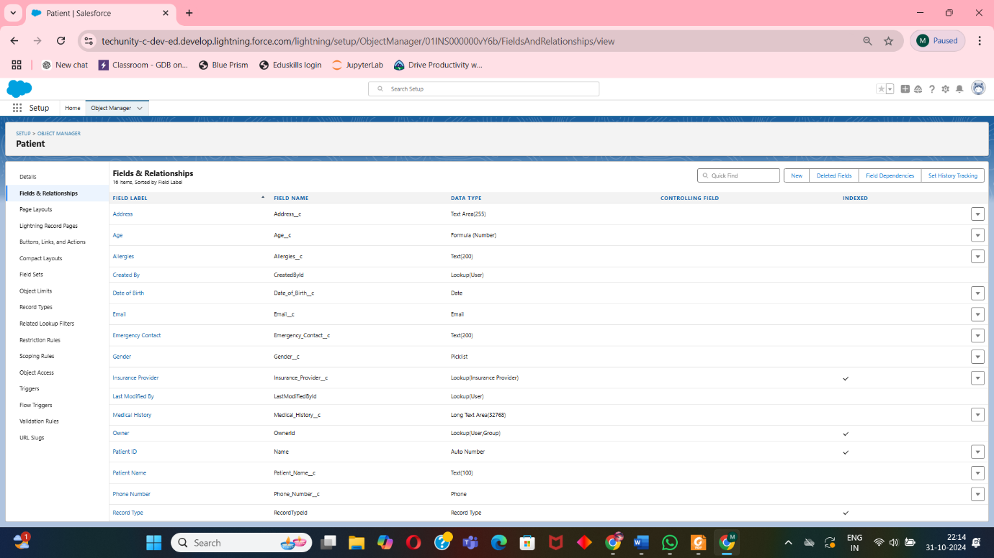

* Appointment Object:
  + Fields: Appointment ID, Date, Time, Status, Reason, Patient (Lookup), Doctor (Lookup), Room (Lookup).
  + Relationships:
    - Lookup Relationship to Patient to link each appointment to a patient.
    - Lookup Relationship to Doctor to assign a doctor for each appointment.
    - Lookup Relationship to Room to allocate rooms for specific appointments.

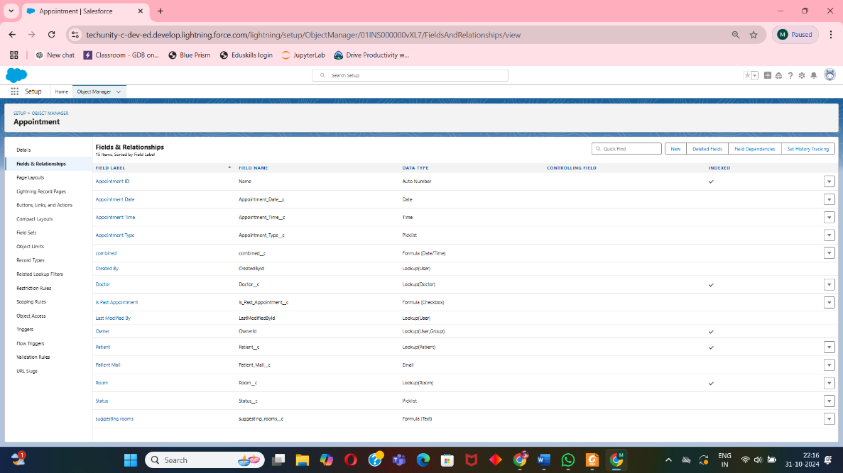

* Doctor Object:
  + Fields: Doctor Name, Doctor ID, Specialization, Department, Contact Number, Email, Availability Schedule.
  + Relationships:
    - One-to-Many relationship with Appointments to manage doctor-patient appointments.

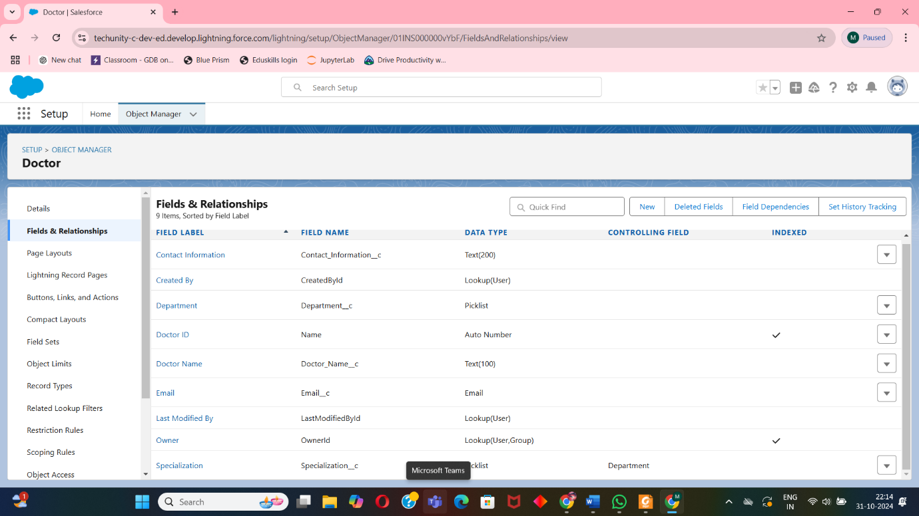

* Room Object:
  + Fields: Room Number, Room Type, Capacity, Status (Available/Occupied), Floor, Equipment Needed (Lookup to Equipment).
  + Relationships:
    - One-to-Many relationship with Appointments for room assignments.
    - Many-to-Many relationship with Equipment to list required equipment in each room.

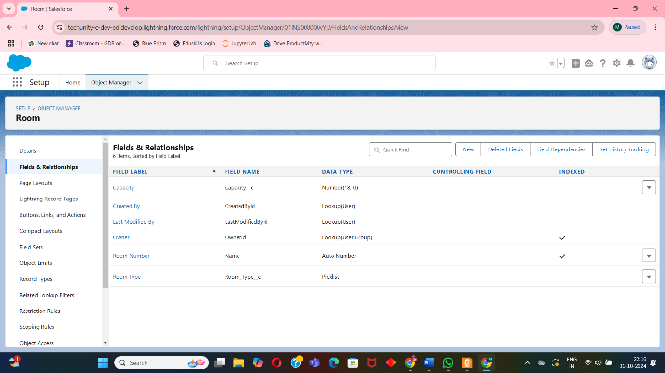

* Equipment Object:
  + Fields: Equipment ID, Equipment Name, Quantity, Status (In Use/Available), Last Maintenance Date.
  + Relationships:
    - Many-to-Many relationship with Room to assign equipment needed per room.

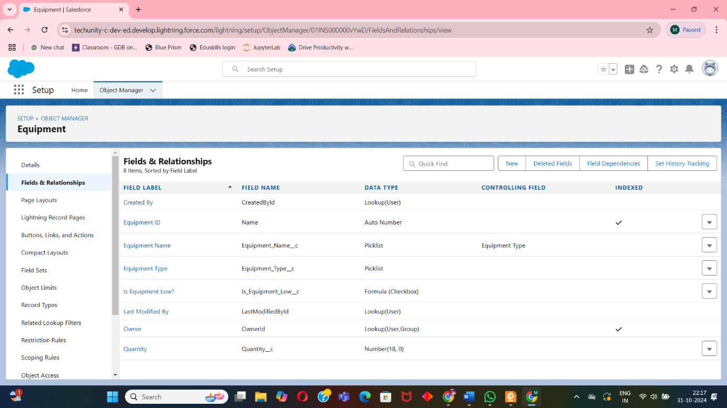

* Billing Object:
  + Fields: Bill Number, Patient (Lookup), Appointment (Lookup), Date, Amount Due, Amount Paid, Payment Status.
  + Relationships:
    - Lookup Relationship to Patient to associate billing with the patient.
    - Lookup Relationship to Appointment to link billing records to specific appointments.

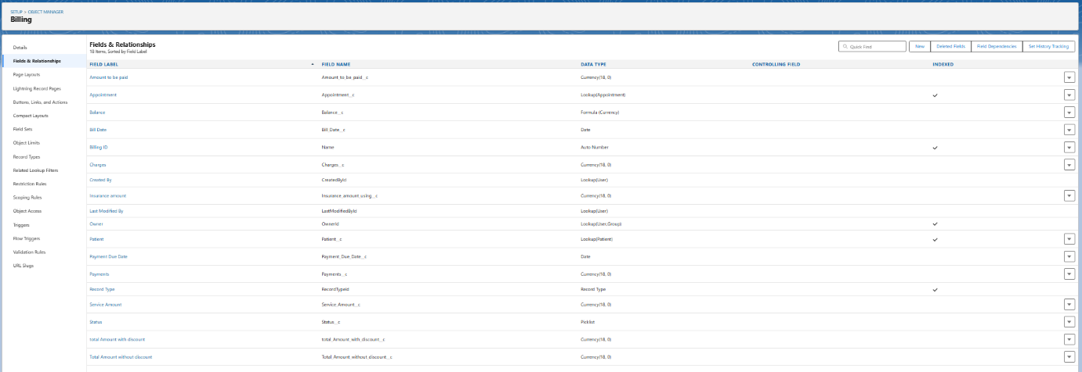

* Staff Object:
  + Fields: Staff Name, Employee ID, Job Title, Department, Contact Number, Email, Schedule.
  + Relationships:
    - One-to-Many relationship with Attendance to monitor staff attendance and schedules.

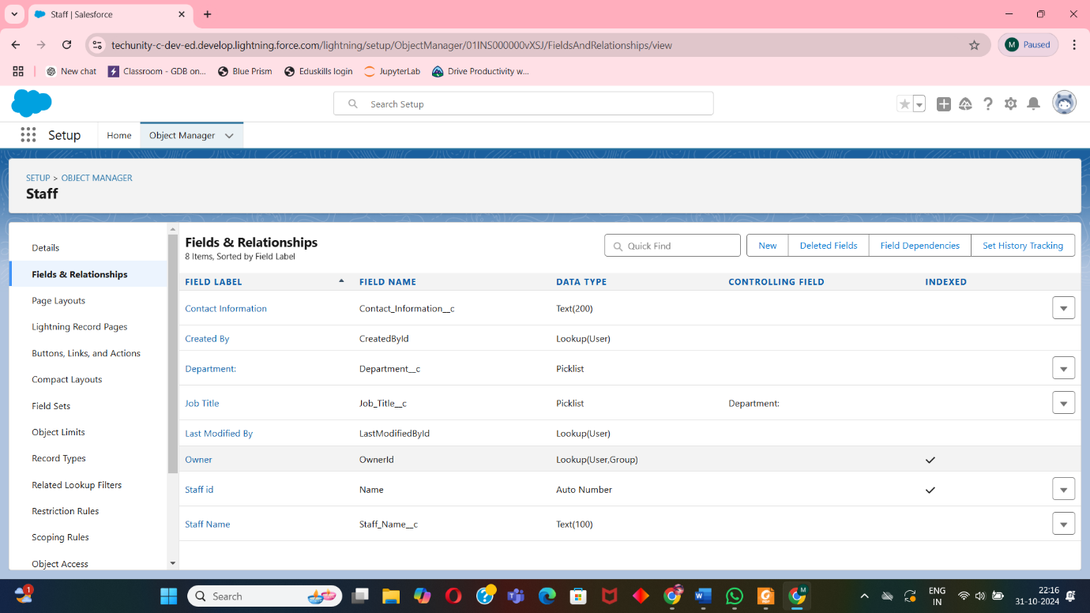

* Attendance Object:
  + Fields: Attendance ID, Staff (Lookup), Date, Check-In Time, Check-Out Time, Status (Present/Absent).
  + Relationships:
    - Lookup Relationship to Staff for tracking daily attendance of each hospital employee.

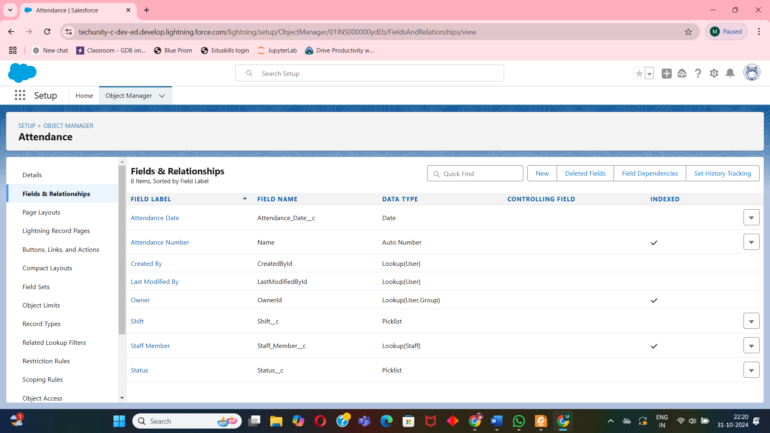

**4.3 Record Types and Page Layouts**

* **Patient Record Types**: Separate layouts for Inpatient and Outpatient to streamline data entry and viewing.

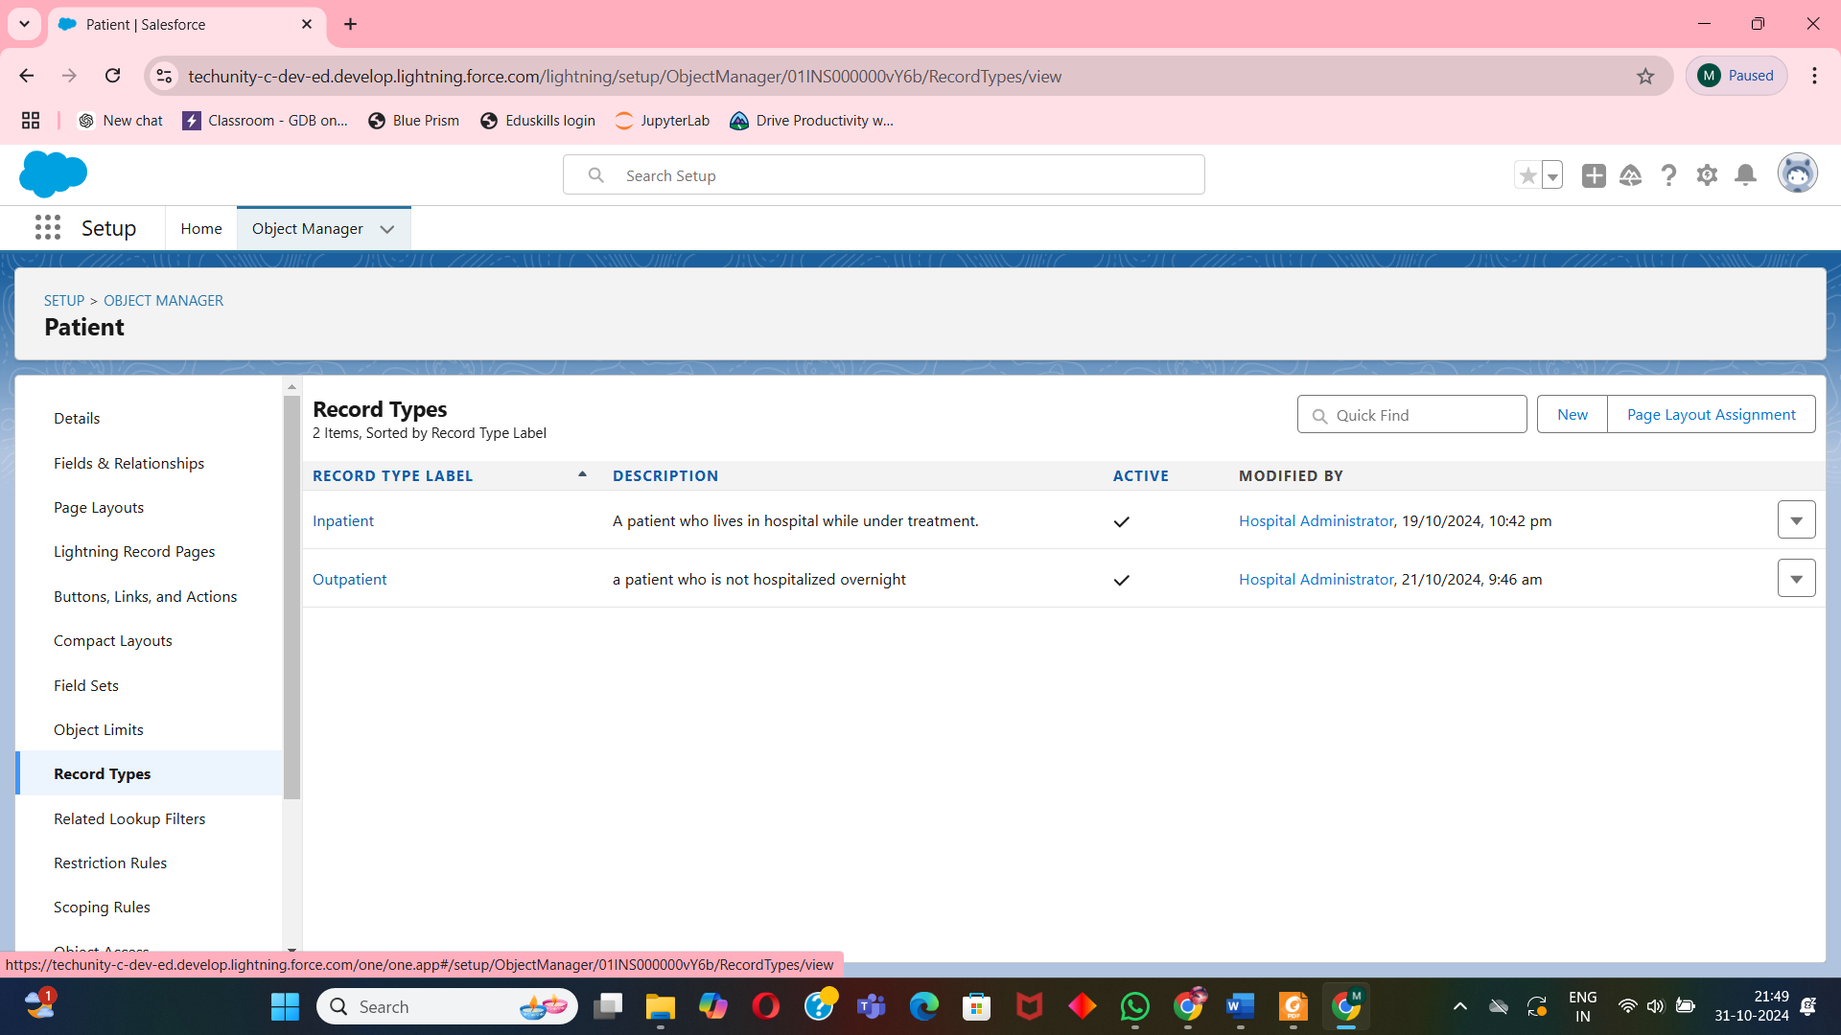

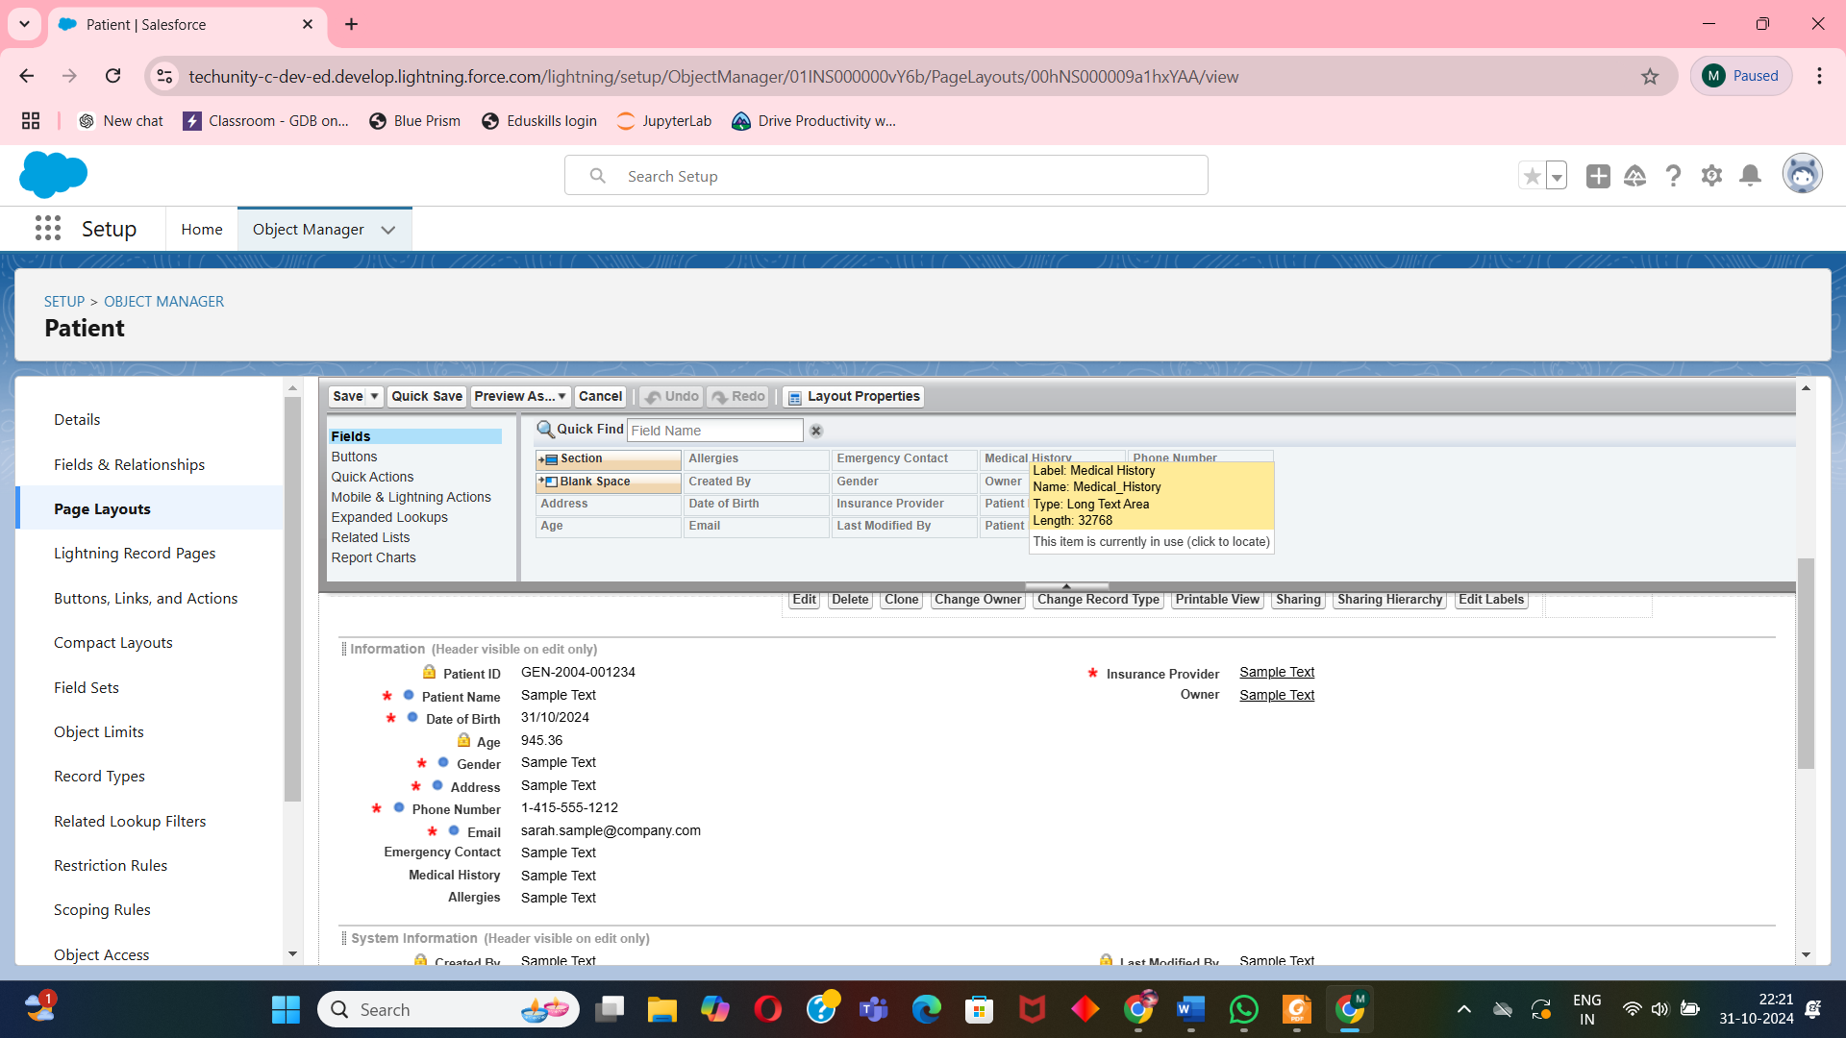

**5. MVP2 - Detailed Dashboard and KPIs**

**5.1 Report Creation**

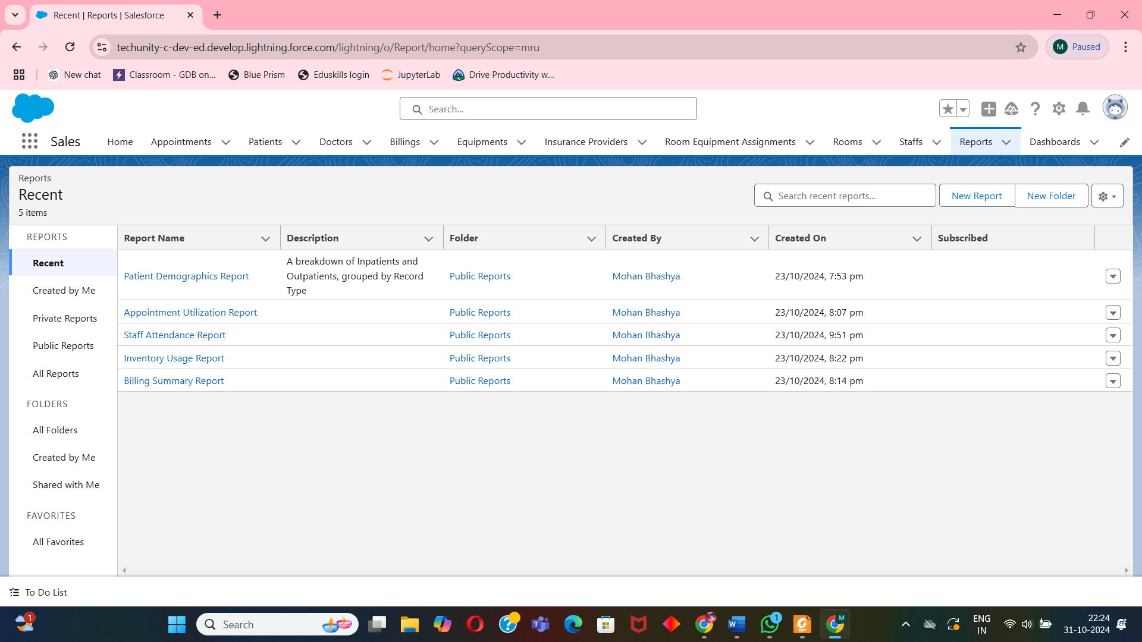

* **Patient Demographics Report**: Provides insights into patient types and demographics.

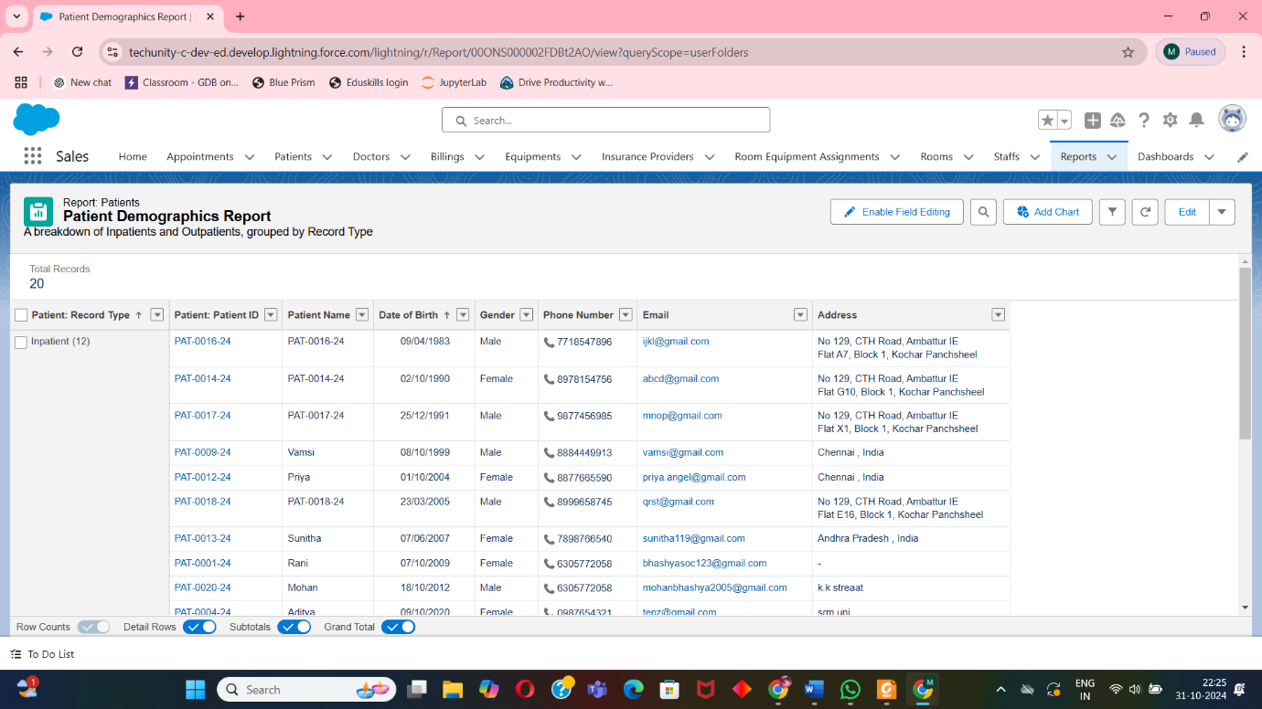

* **Appointment Utilization Report**: Analyzes appointment scheduling and doctor availability.

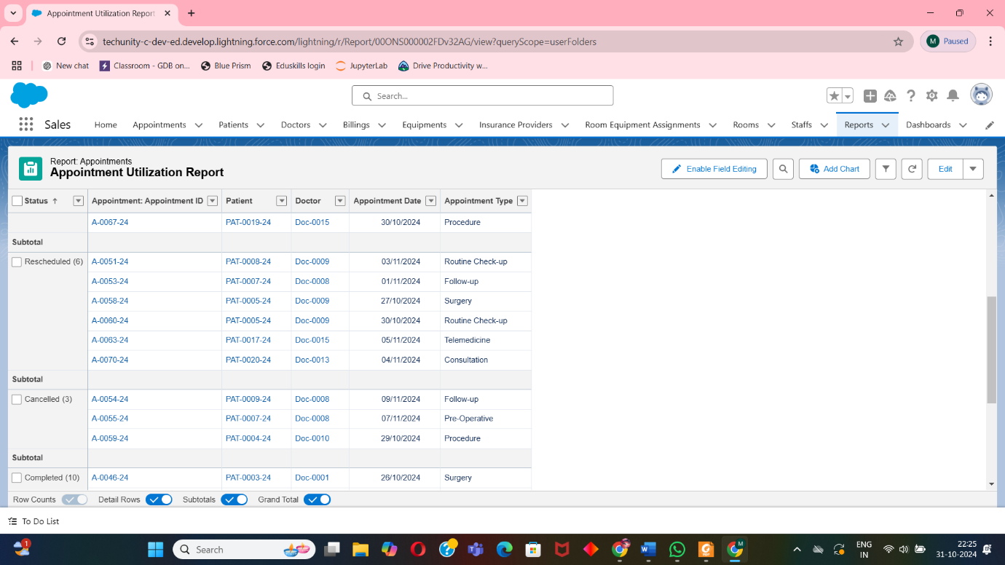

* **Billing Summary Report**: Summarizes billing amounts, outstanding payments, and revenue.

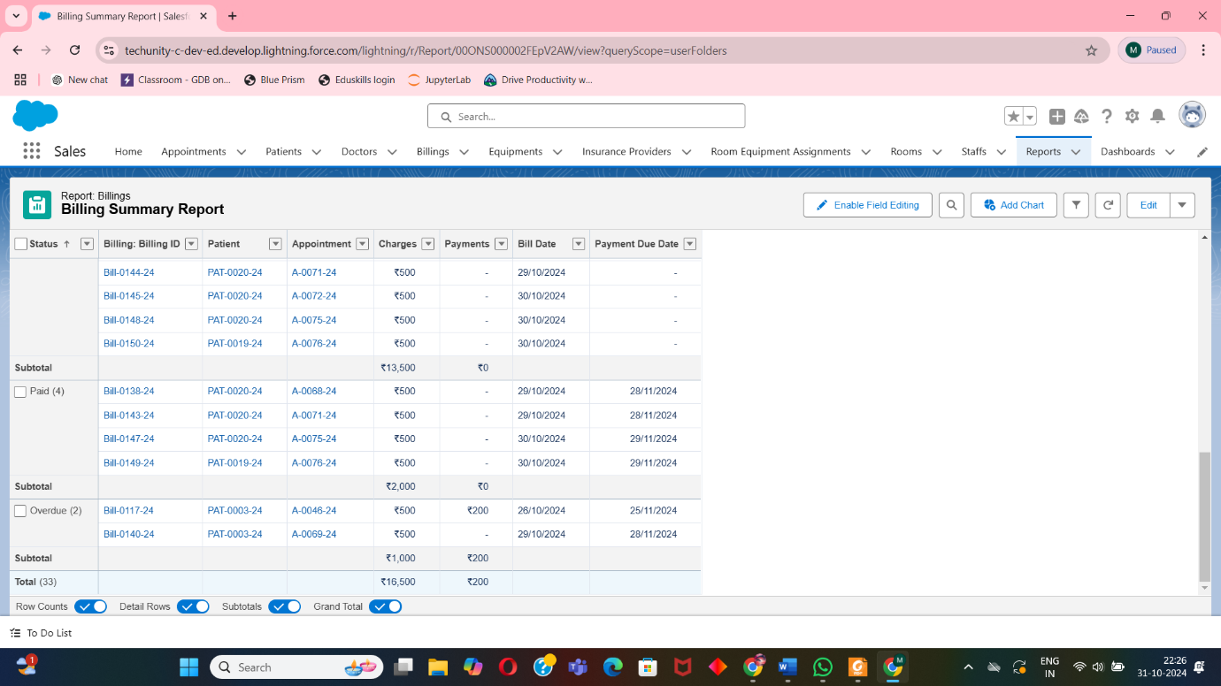

* **Inventory Usage Report**: Tracks medical supplies and stock levels.

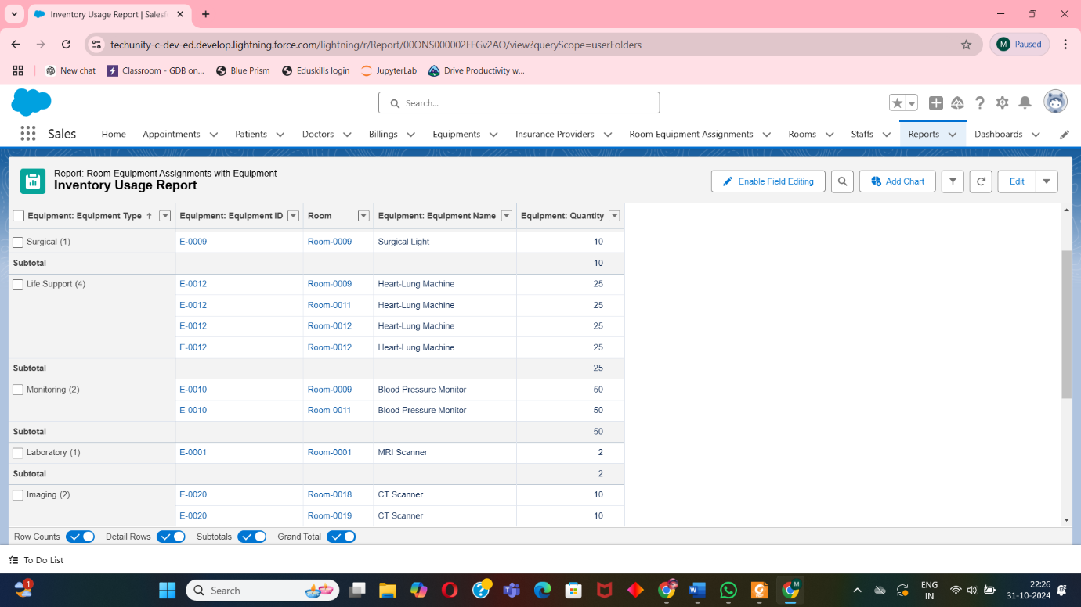

* **Staff Attendance Report**: Monitors staff schedules and attendance.

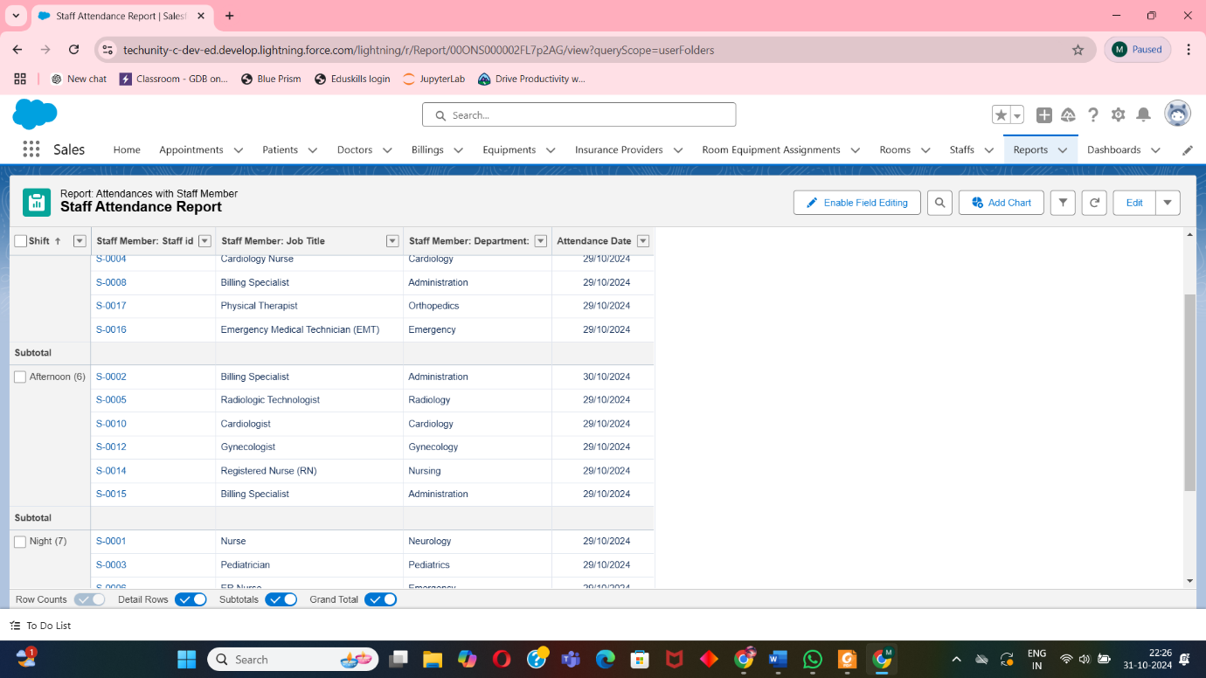

**5.2 Dashboard Development**

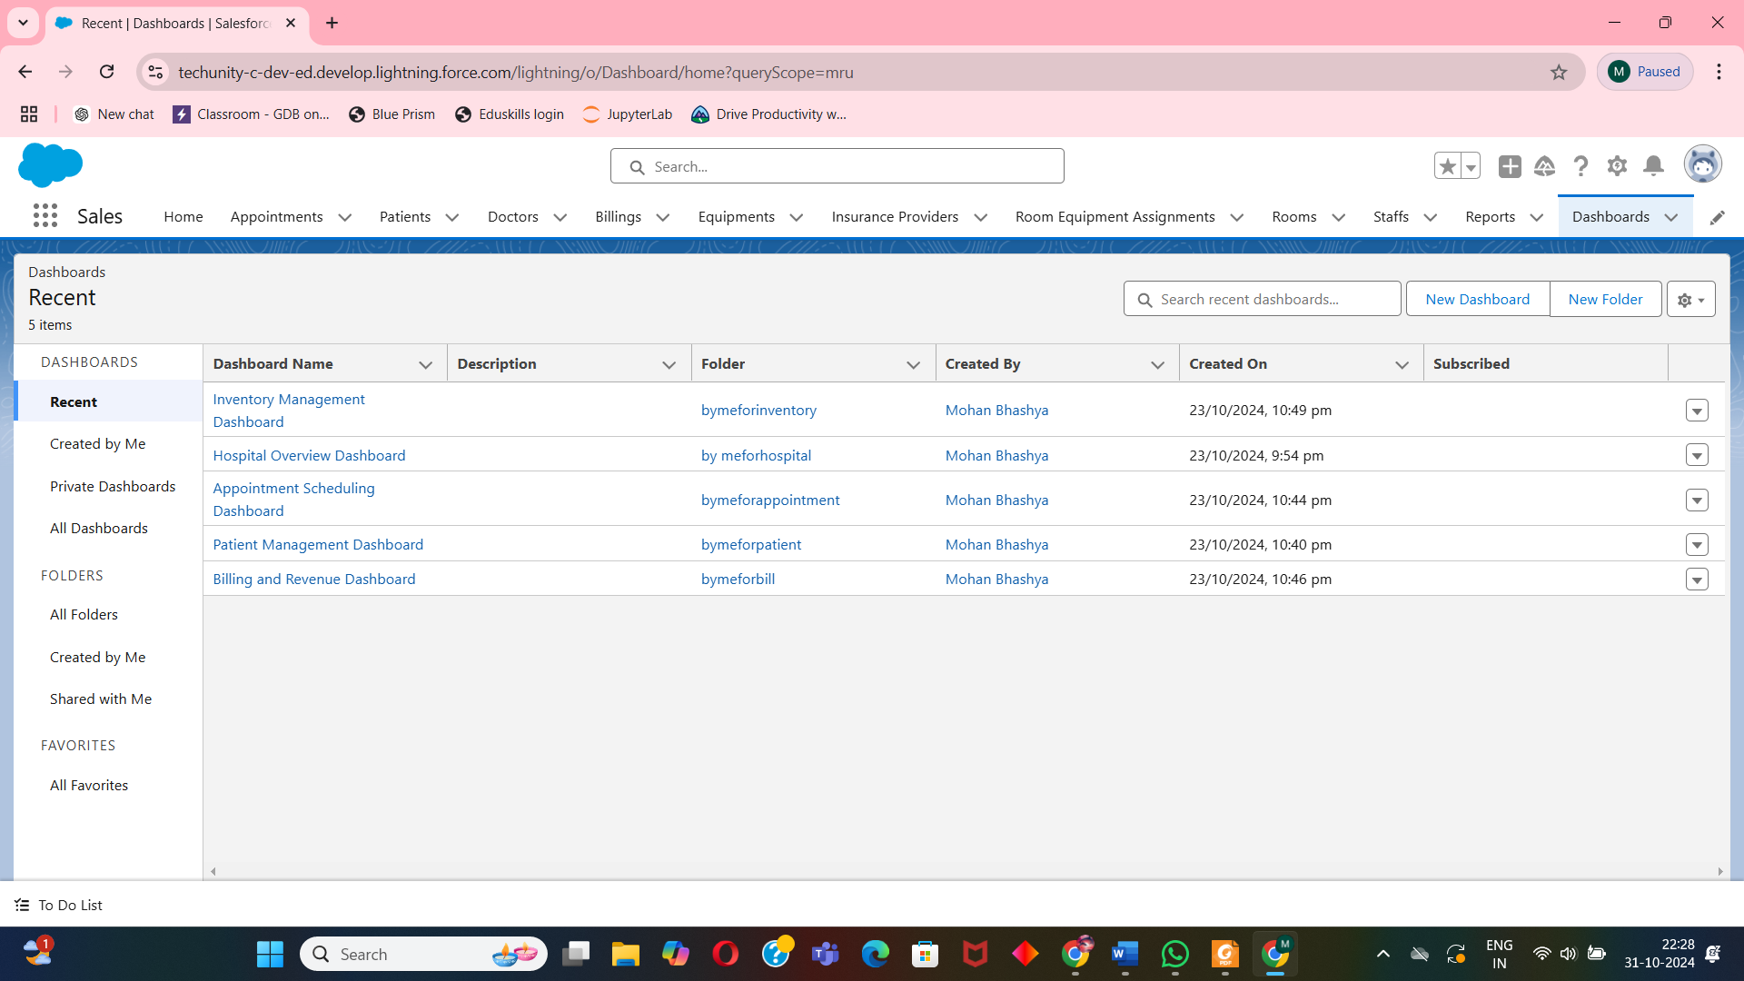

* **Hospital Overview Dashboard**: Comprehensive view of hospital operations.

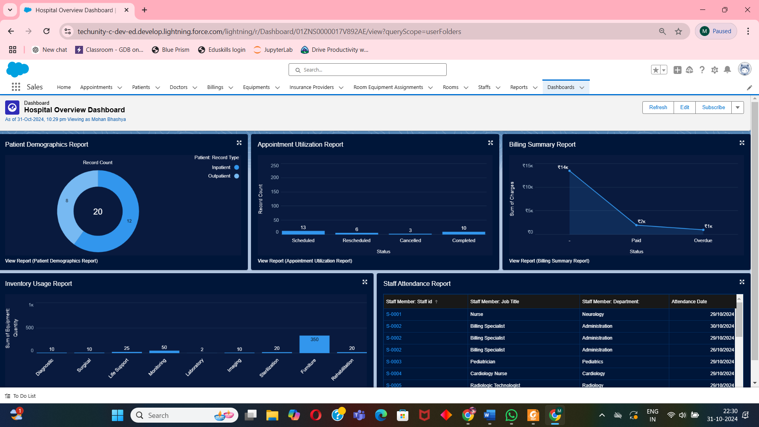

* **Patient Management Dashboard**: Patient data and demographics.

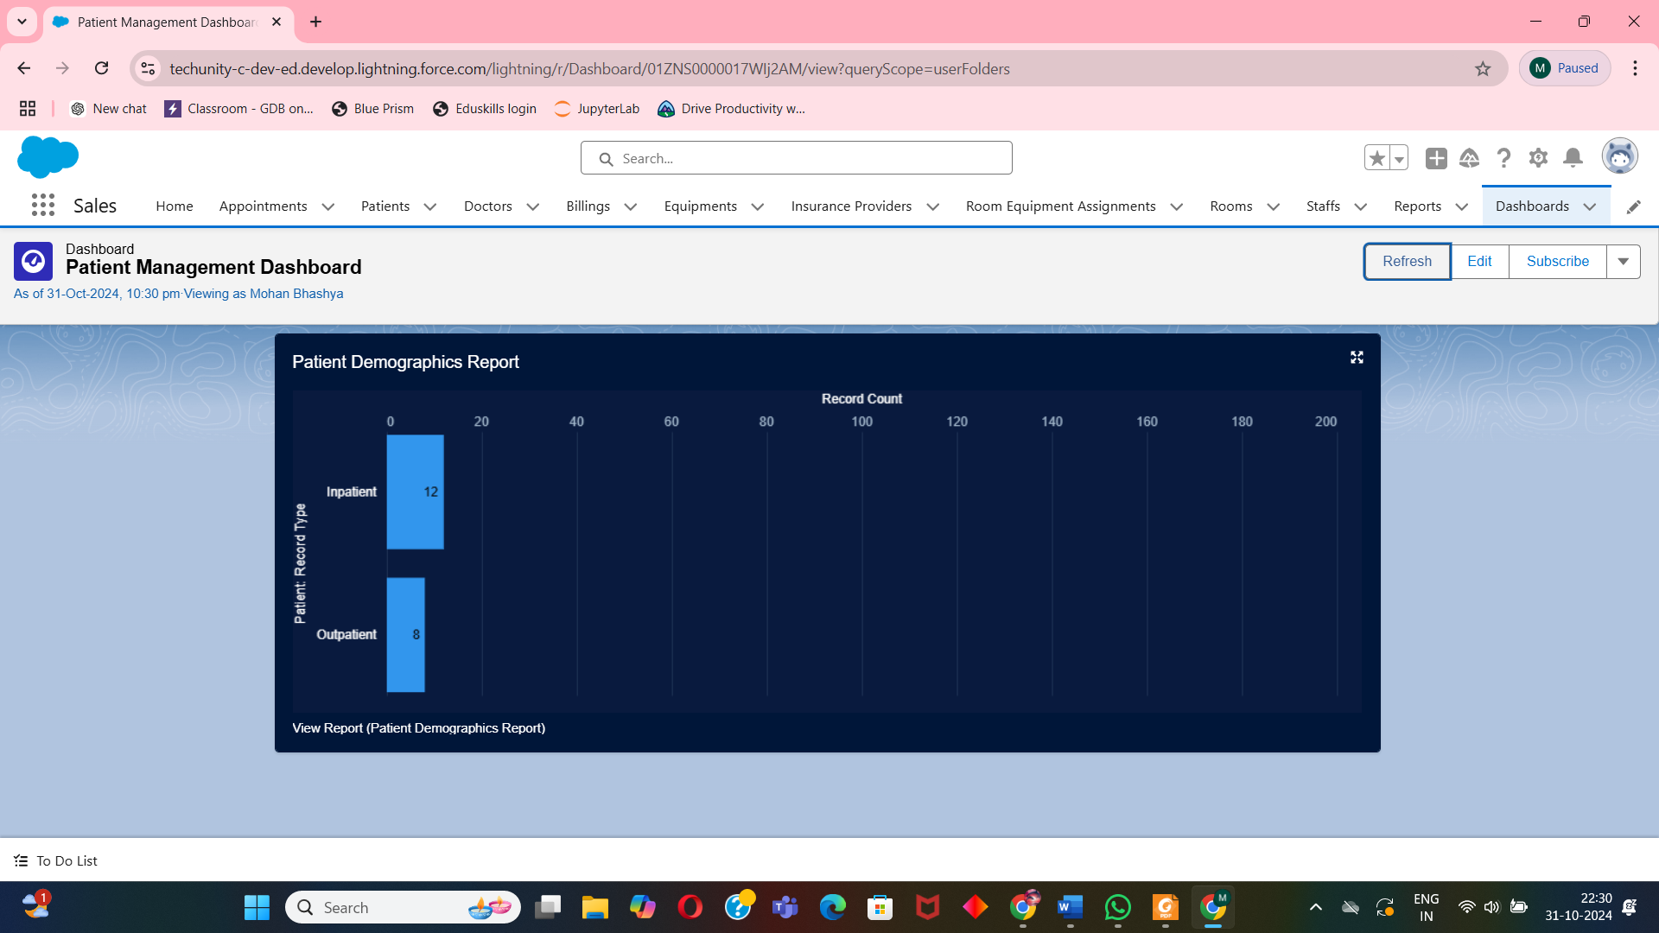

* **Appointment Scheduling Dashboard**: Real-time insights into scheduled appointments.

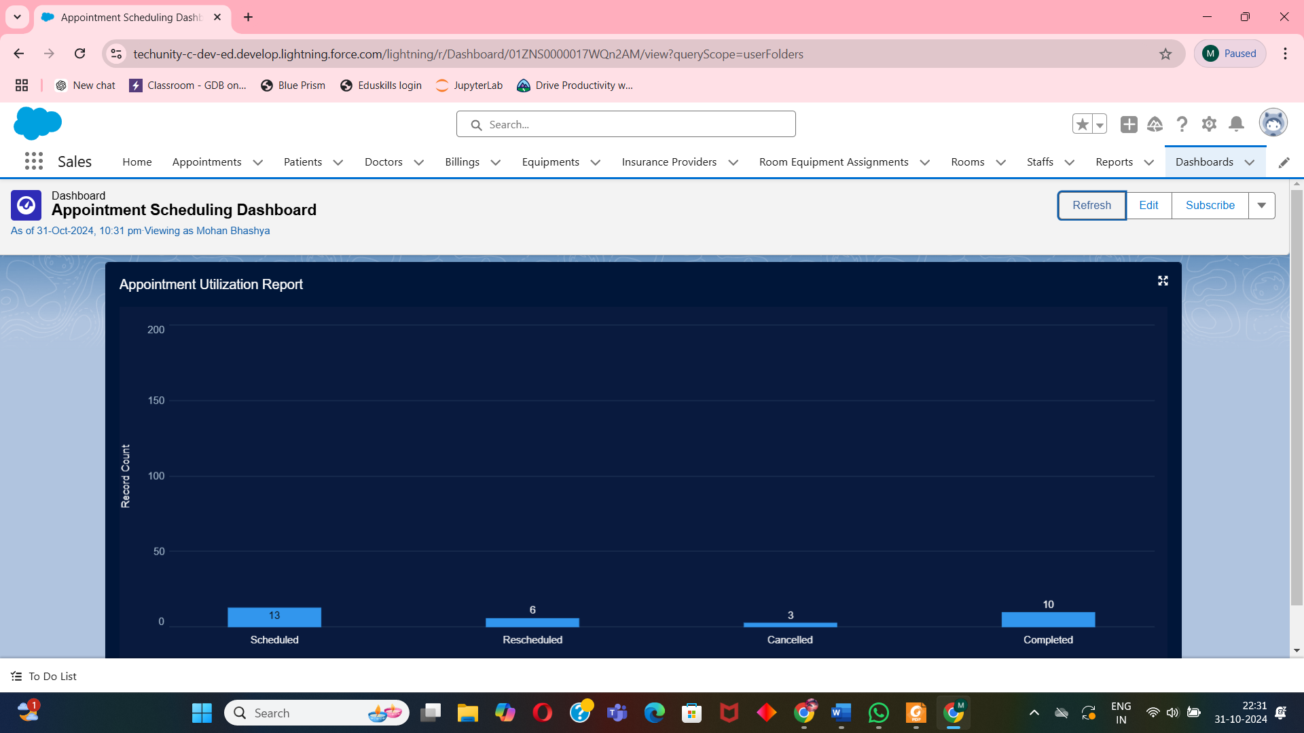

* **Billing and Revenue Dashboard**: Tracks revenue and payment statuses.

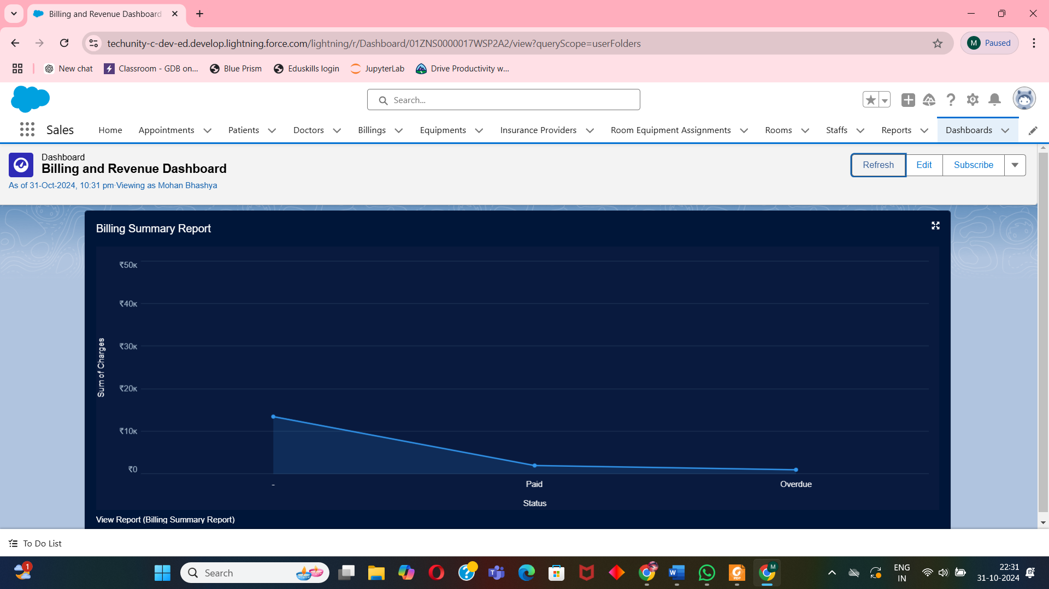

* **Inventory Management Dashboard**: Displays inventory status and alerts.

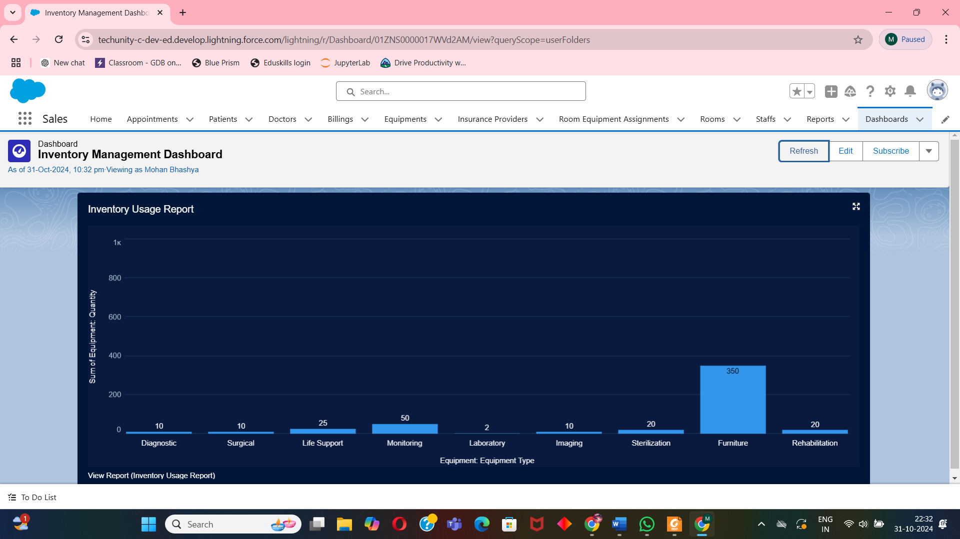

**6. UI/UX Design**

**6.1 Layout Design**  
The layout will provide:

* Quick access tabs for each department (Patient Management, Appointments, Billing, Inventory, Staff etc).
* Dashboard sections for role-specific data, enabling streamlined access to reports.
* Alerts and notifications for important tasks, e.g., billing reminders and inventory alerts.

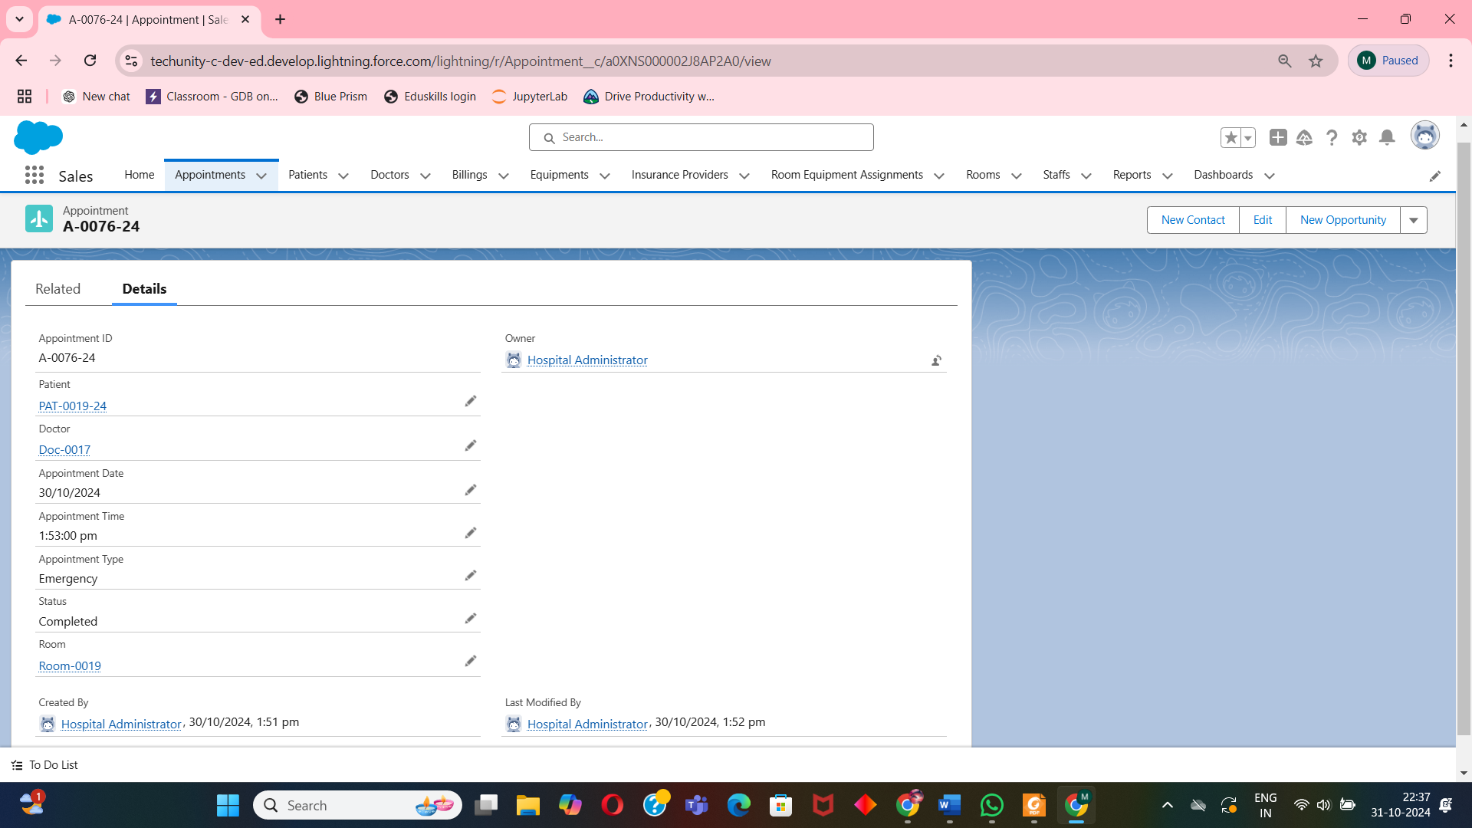

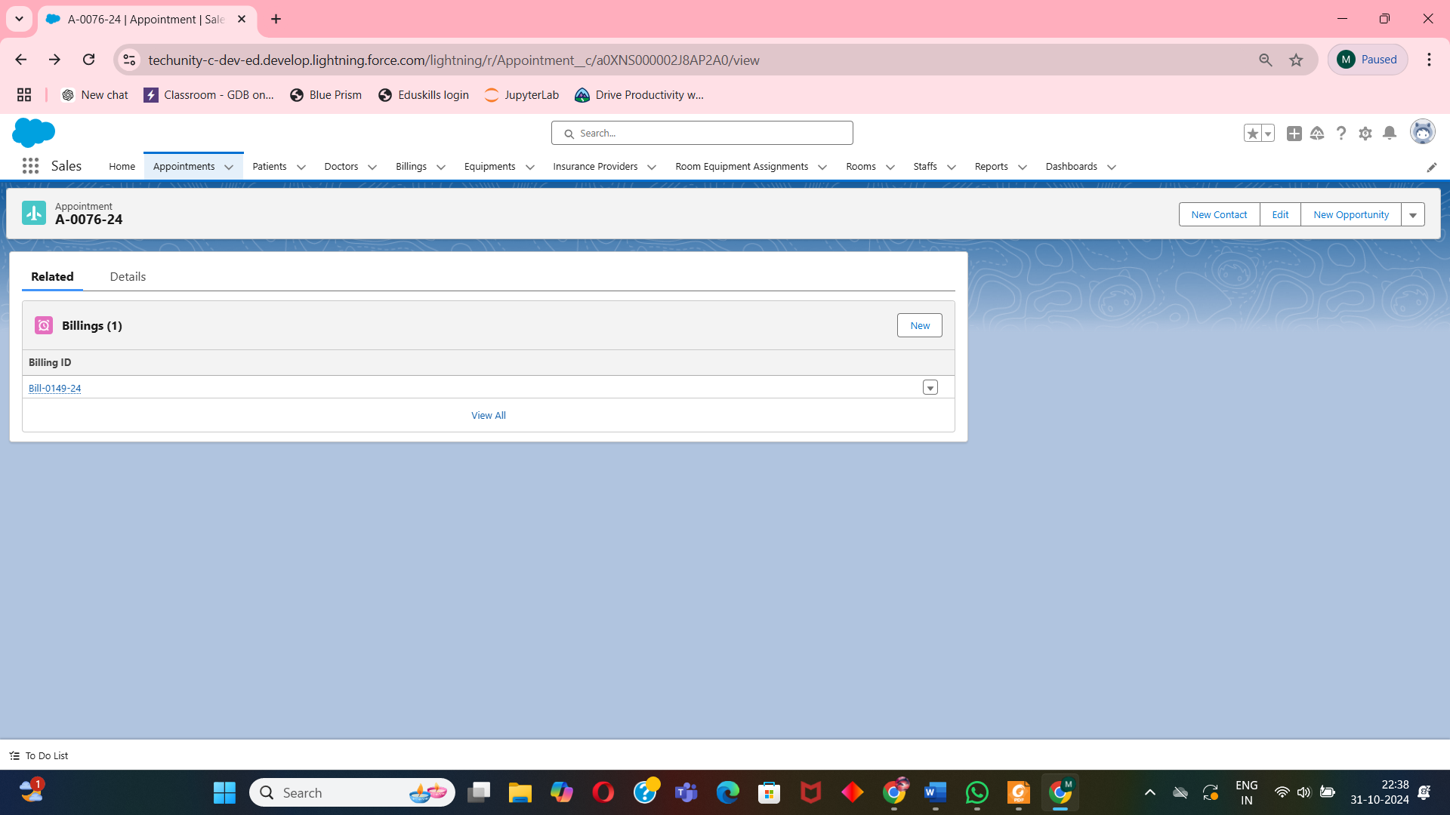

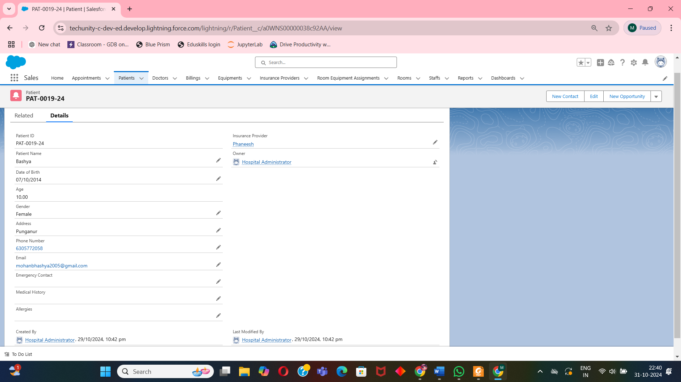

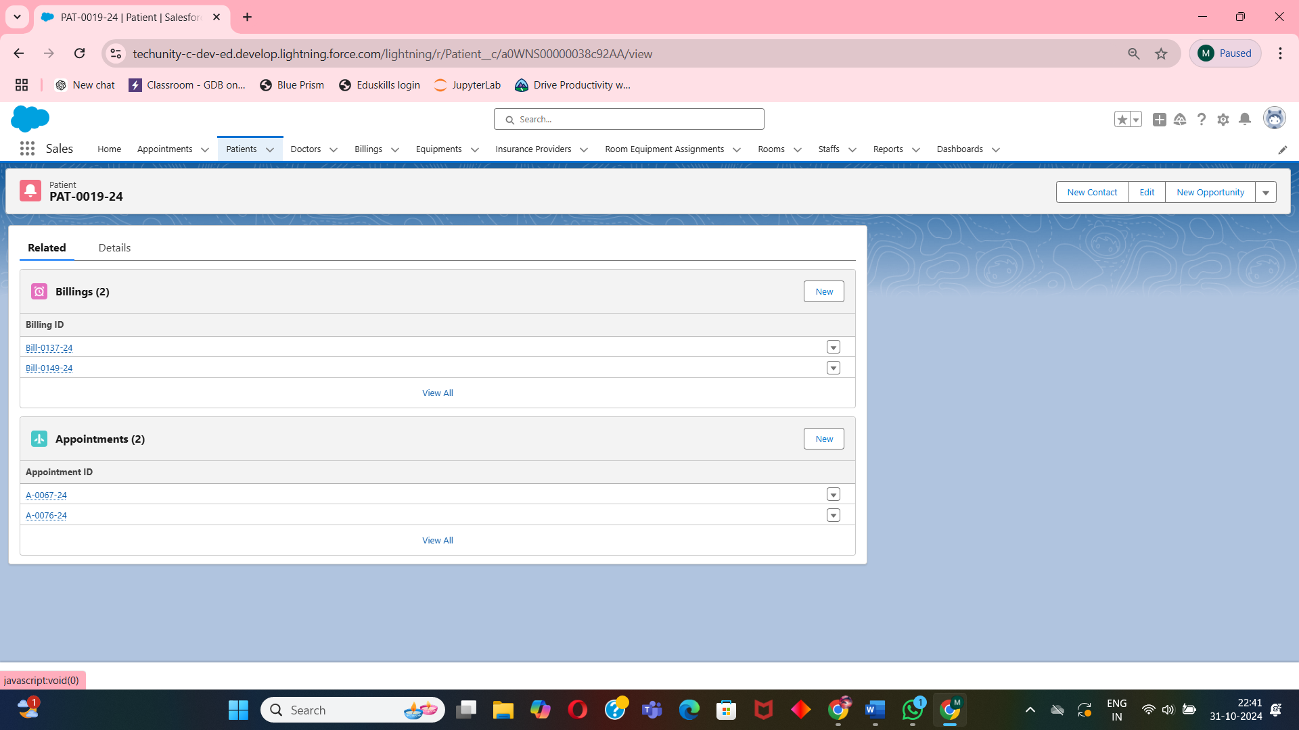

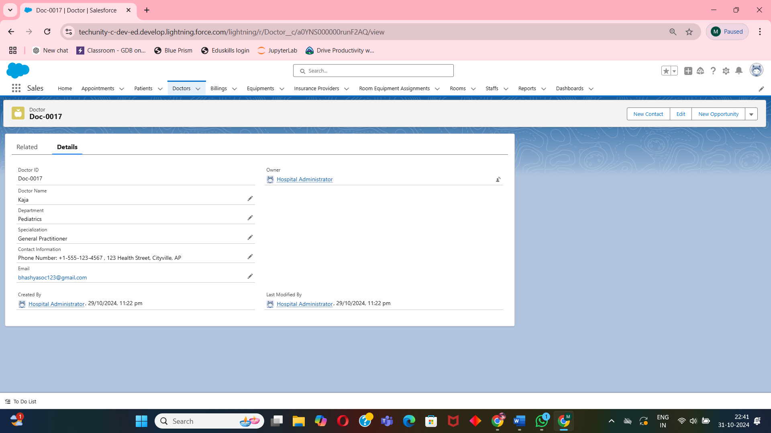

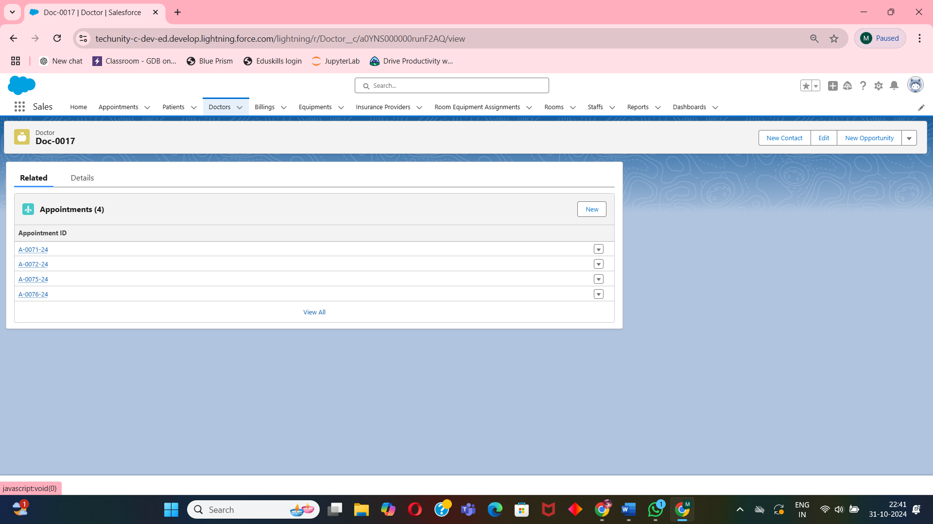

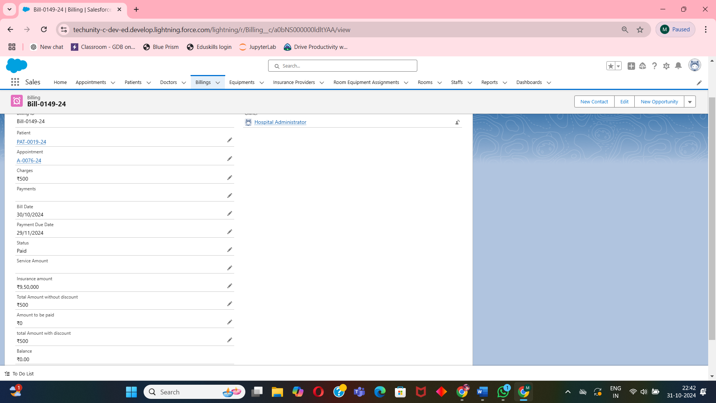

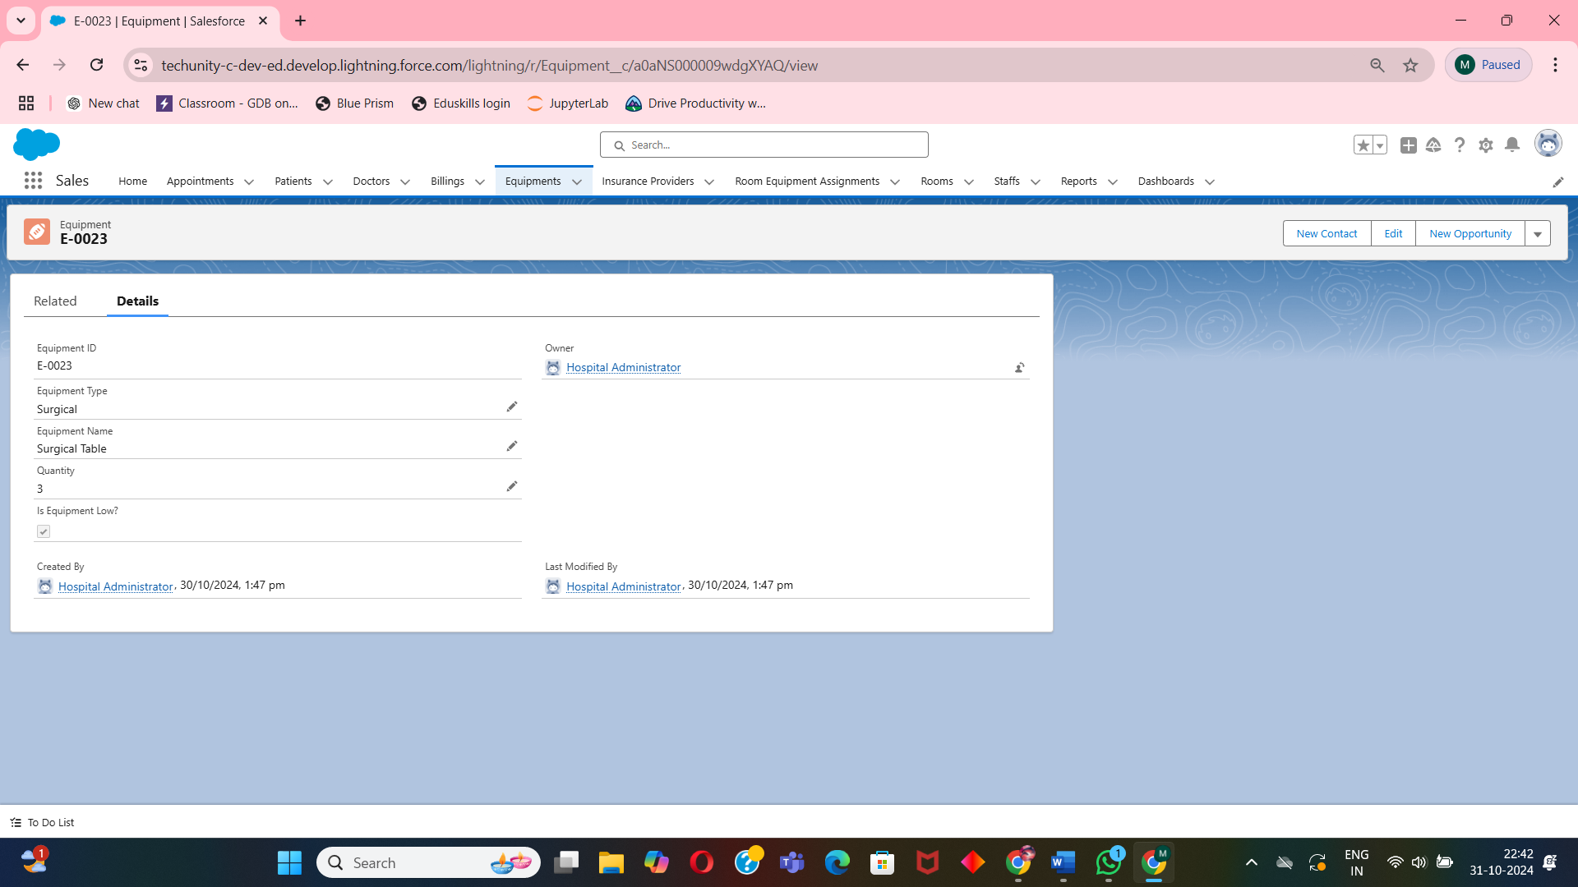

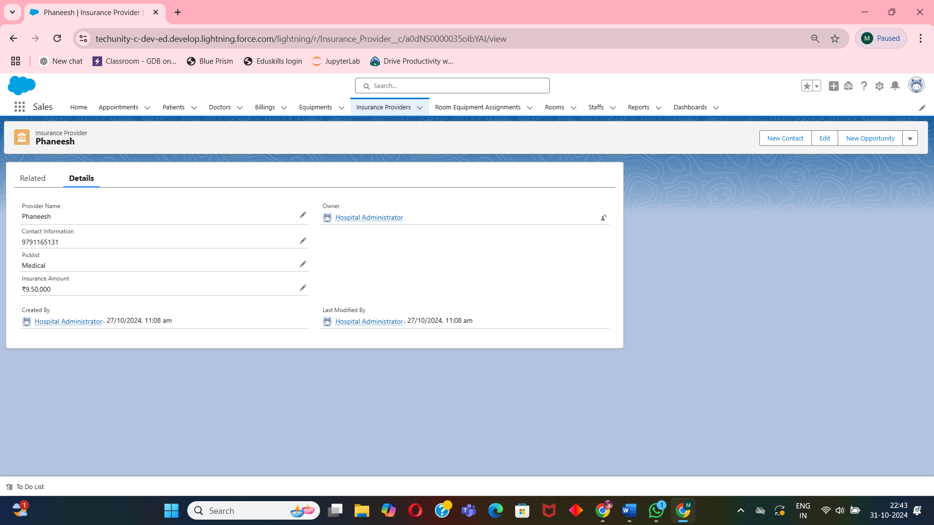

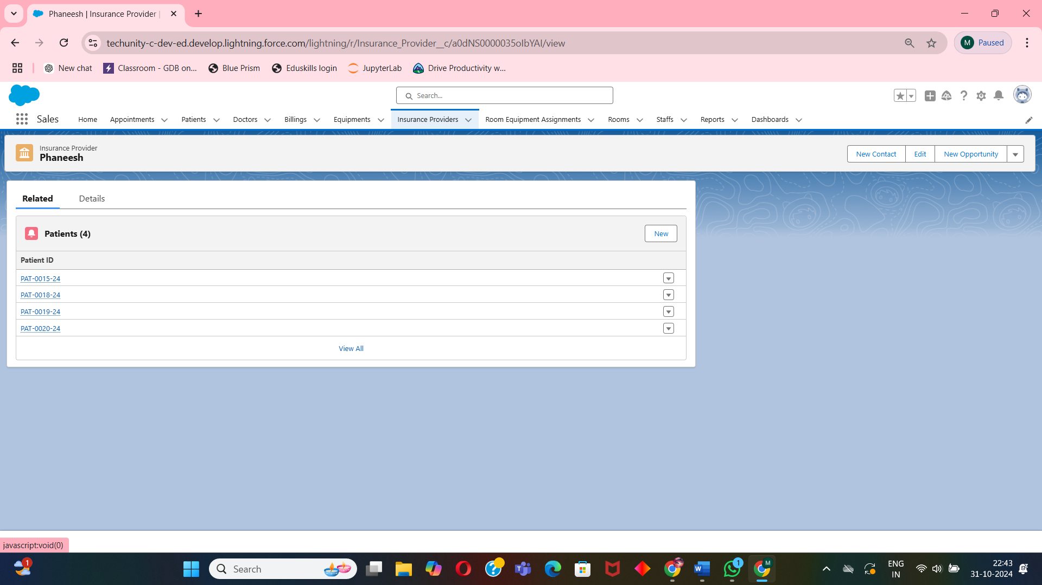

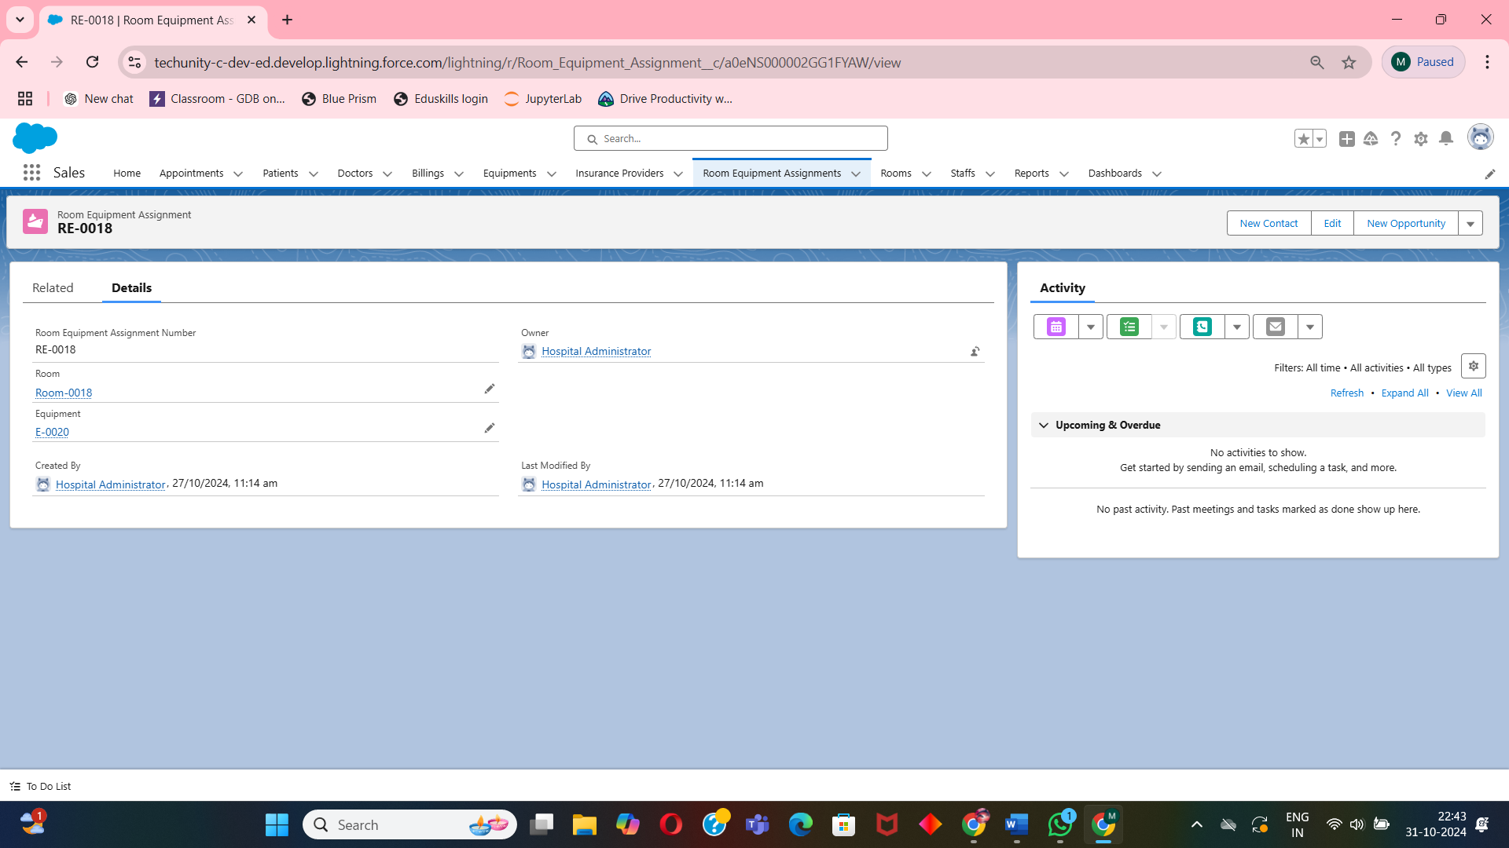

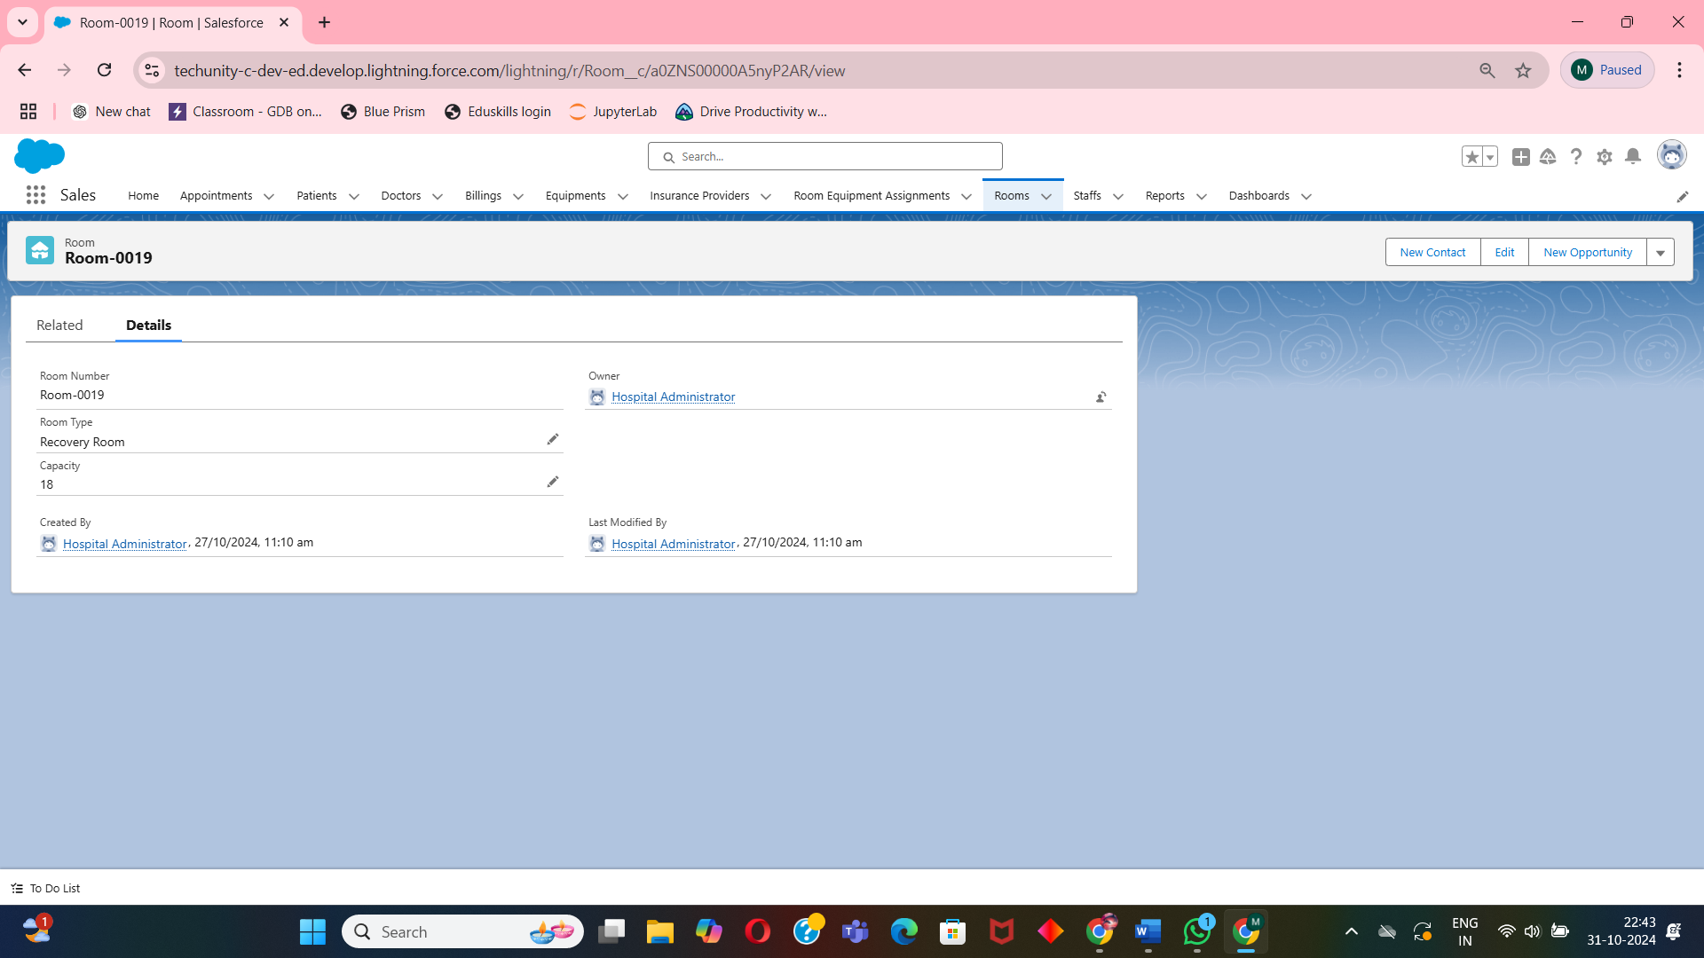

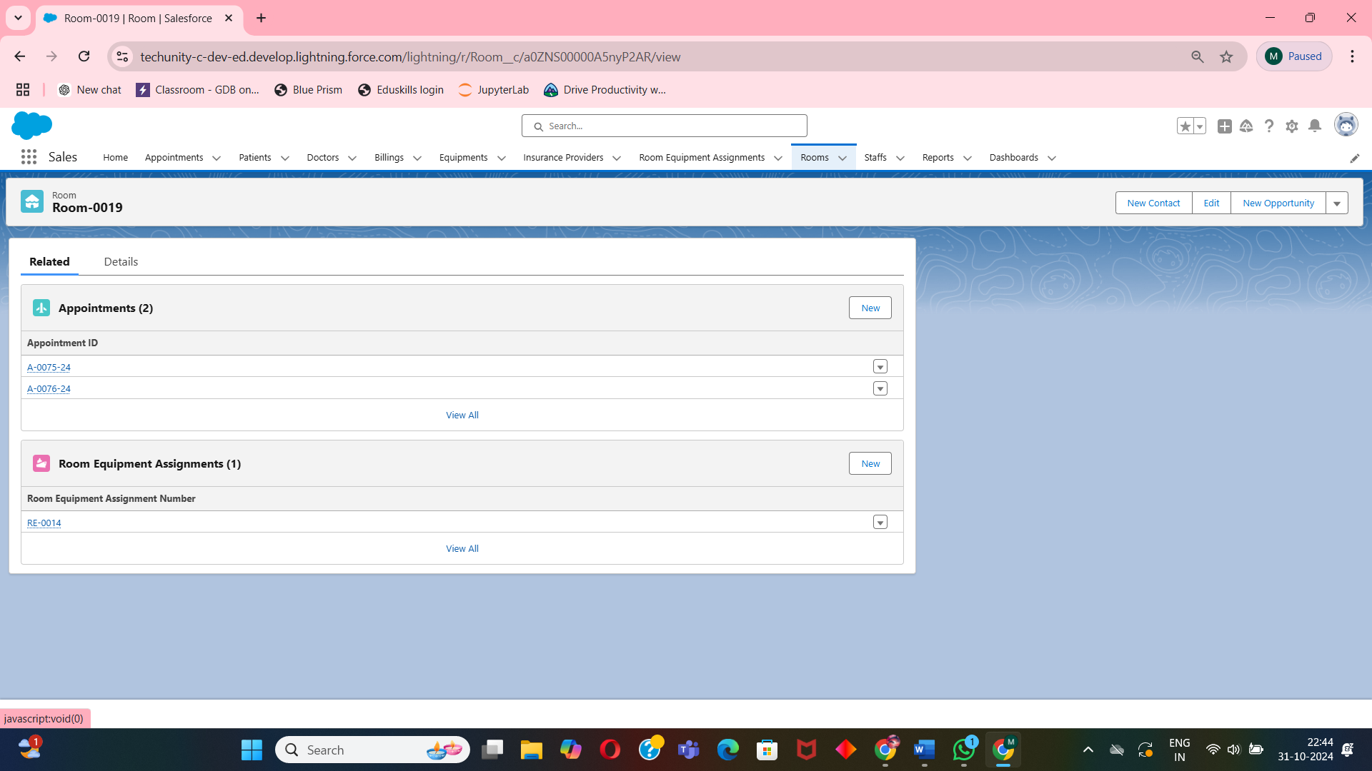

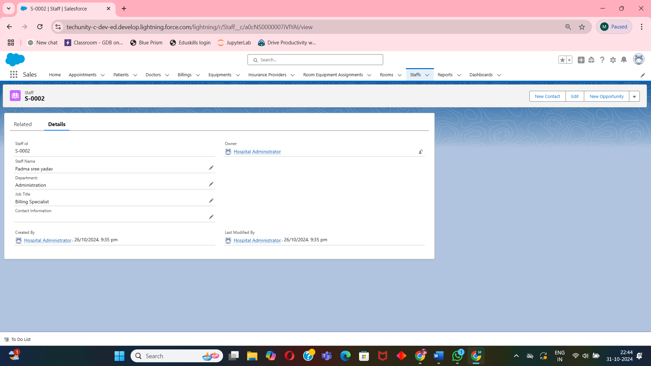

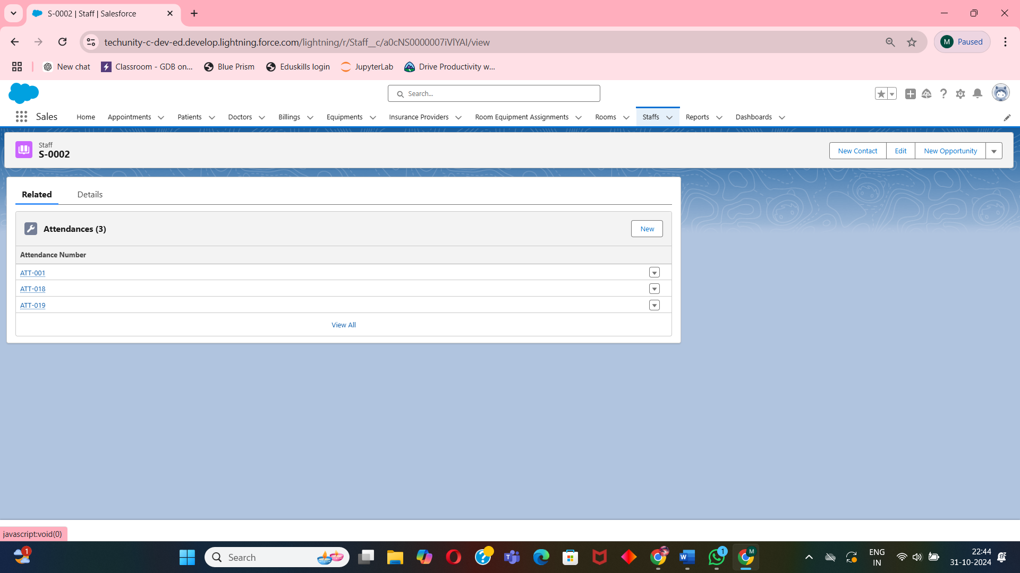

**7. Conclusion**

**7.1 Summary of the Project**  
The project’s primary goal was to digitize and streamline hospital management operations using Salesforce, focusing on the integration of patient management, appointment scheduling, billing, inventory control, and staff scheduling. The application centralizes and automates hospital processes, making it easier for administrators, doctors, and other staff to manage daily tasks efficiently.

Through custom objects, automated flows, and scheduled reminders, the application ensures accurate record-keeping, timely billing, and effective resource allocation within the hospital. Custom reports and dashboards provide hospital administrators with real-time data on key performance indicators, supporting informed decision-making. The successful implementation of this project highlights an understanding of Salesforce features, such as custom object creation, Apex programming, automation via flows, and report generation. This project bridges the gap between theoretical learning and practical application, showcasing the ability to develop and deploy a complete hospital management solution within Salesforce.

**7.2 Acknowledgments**  
This project was developed with the support and guidance of mentors, course instructors, and peers. I would like to extend my gratitude to the instructors for their insights and assistance throughout the project, which helped build a strong understanding of Salesforce development.

Special thanks to my peers for their collaborative spirit and constructive feedback, which played a vital role in refining the application. Additionally, resources from the Salesforce Trailhead community were invaluable in learning advanced concepts and best practices, making the development of this application possible through a blend of formal instruction, peer collaboration, and extensive Salesforce learning resources.